Ex 4 A2 Shopping
Name: ____________________________ Surname: ____________________________ N^{ber}: ____ Grade/Class: _____
Assessment: _____________________________ | Date: ___________________________________________________
 | Teacher’s signature:  ___________________________ | Parent’s signature:  ___________________________

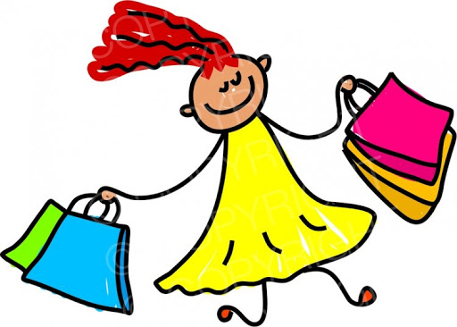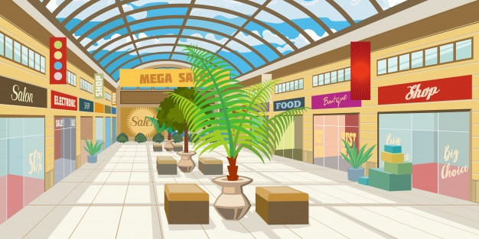
What shops are there in this shopping mall? Write YES or NO next to the shops below.

I love going to our local mall! There are so many shops in it and you can buy whatever you need.
There are a lot of shops selling clothes and sportswear. There is a huge supermarket where you can find anything you want.
There is a lovely café on the first floor where I meet my friends.
Unfortunately, there is no bakery so I have to get bread from the one next to my house.
Also, you cannot find a pharmacy in our mall.
1. Supermarket --------
2. Sports shop --------
3. Pharmacy --------
4. Bakery --------
5. Café --------

