Exercise 5 A2 Shopping
Name: ____________________________ Surname: ____________________________ N^{ber}: ____ Grade/Class: _____
Assessment: _____________________________ | Date: ___________________________________________________
 | Teacher’s signature:  ___________________________ | Parent’s signature:  ___________________________

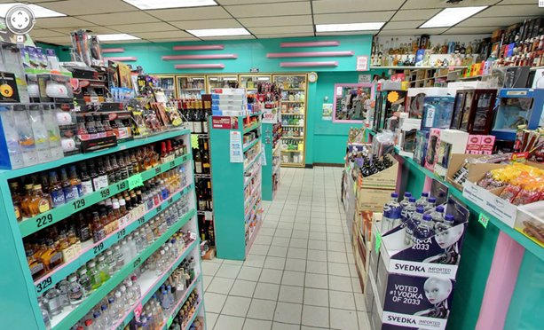

Match the shops with their shopping vocabulary:
bakery /café /post office/ supermarket /chemist(pharmacy)

- …………………….. a. stamps, letters , envelops

2.…………………….. b. medicine, pills, vitamins

3.………………………. c. bread, sweets, cakes

4. ………………………. d. coffee, tea, juice

- ………………………. e. fruit, cheese, meat

Key: 1. Post office 2. Chemist(pharmacy) 3. Bakery 4. Café 5. Supermarket

