TOPIC: Shopping | SUBTOPICS: Vocabulary | LEVEL: A2
Name: ____________________________ Surname: ____________________________ N^{ber}: ____ Grade/Class: _____

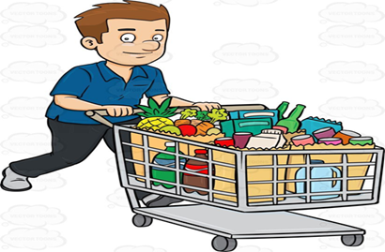

Peter went to the supermarket today. Let’s see what he has got.

Peter’s shopping list:

Unscramble the letters to write the correct names of the things Peter got from the supermarket today:

1. ELOMSN _____________________
2. RONAEGS _____________________
3. RBAED ______________________
4. PALPSE ______________________
5. RTSBWARRESEI ______________________
6. EEHCES ______________________
7. IMKL ______________________
8. EMTA ______________________

KEY: 1. LEMONS 2 ORANGES 3. BREAD 4. APPLES 5. STRAWBERRIES 6. CHEESE 7. MILK 8. MEAT

