Ex 5 A2 Shopping
Name: ____________________________ Surname: ____________________________ N^{ber}: ____ Grade/Class: _____
Assessment: _____________________________ | Date: ___________________________________________________
 | Teacher’s signature:  ___________________________ | Parent’s signature:  ___________________________

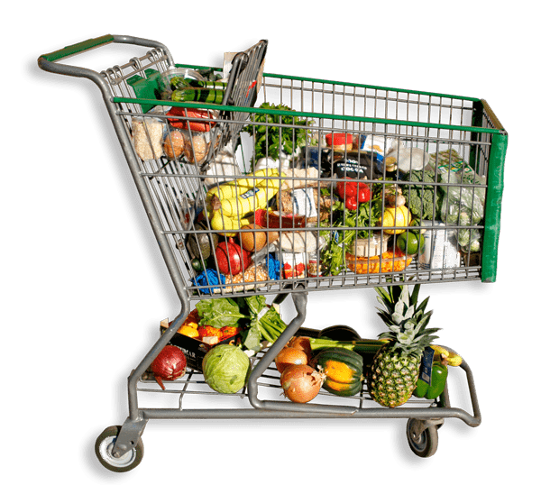
At a supermarket.
Write 10 things you can buy at a supermarket. E.g. Eggs
- ------------------------------------------
- ------------------------------------------
- ------------------------------------------
- ------------------------------------------
- ------------------------------------------
- ------------------------------------------
- ------------------------------------------
- ------------------------------------------
- ------------------------------------------
- -------------------------------------------

