Ex. 1 A1 Sports
Name: ____________________________ Surname: ____________________________ N^{ber}: ____ Grade/Class: _____
Assessment: _____________________________ | Date: ___________________________________________________
 | Teacher’s signature:  ___________________________ | Parent’s signature:  ___________________________
Listen and color.

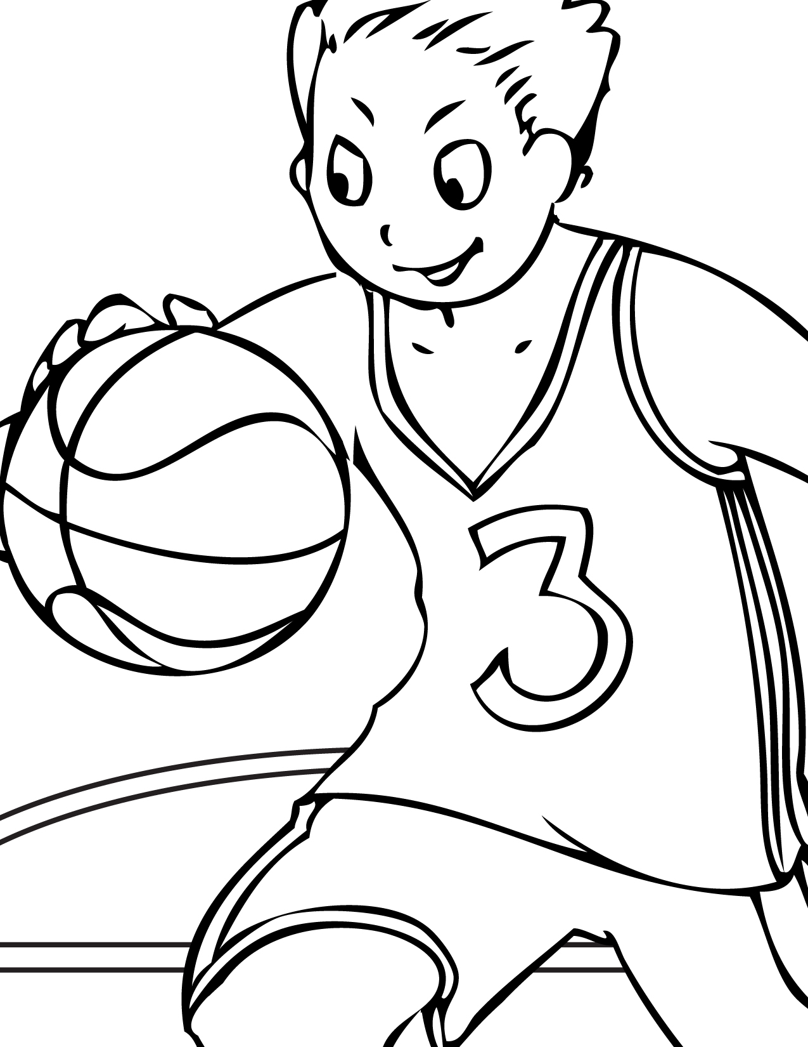

Transcript:
Michael is playing basketball today. His team must win this game and he is trying hard.
He is wearing his team’s colors; a yellow basketball vest and a pair of blue shorts. The number on his vest is green and the ball is red.

