Exercise 3 A1 Sports
Name: ____________________________ Surname: ____________________________ N^{ber}: ____ Grade/Class: _____
Assessment: _____________________________ | Date: ___________________________________________________
 | Teacher’s signature:  ___________________________ | Parent’s signature:  ___________________________

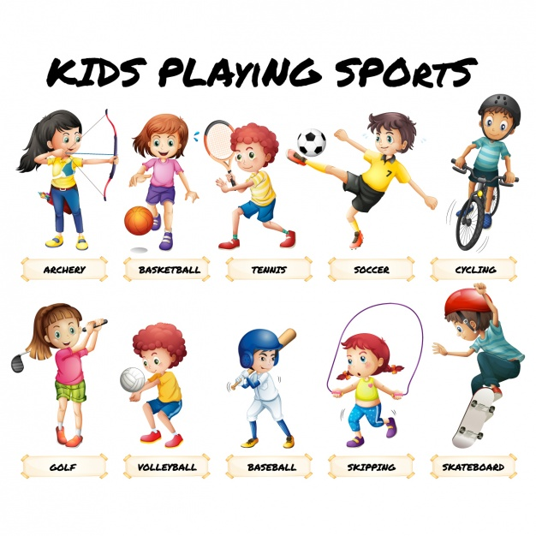

Which sport you (like √) and which one you (don’t like X)
Look at the pictures above and write 5 sentences based on the photographs.
1. --------------------------------------------------------------
2. --------------------------------------------------------------
3. --------------------------------------------------------------
4. --------------------------------------------------------------
5. ---------------------------------------------------------------

