TOPIC: Sports | SUBTOPICS: Vocabulary | LEVEL: A2
Name: ____________________________ Surname: ____________________________ N^{ber}: ____ Grade/Class: _____

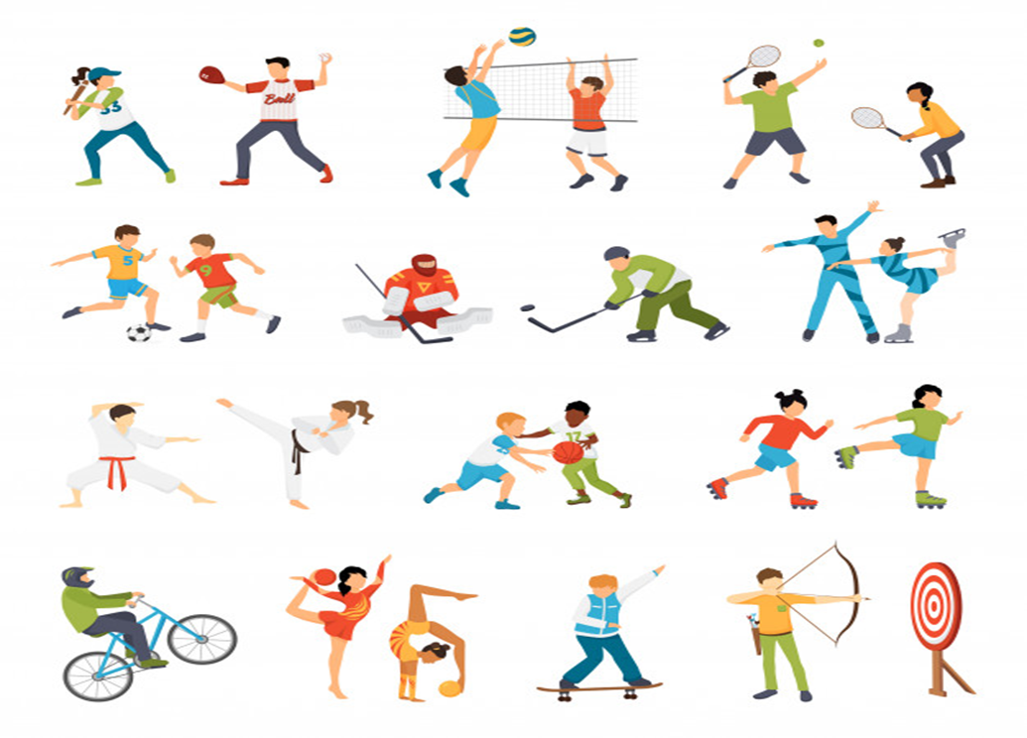
Write the name of the sports shown in the picture that you need a ball to play with. The first letter is given for you:

1. B_ _ _ _ _ _ _ _
2. V _ _ _ _ _ _ _ _ _
3. T _ _ _ _ _
4. F_ _ _ _ _ _ _
5. H_ _ _ _ _
6. B _ _ _ _ _ _ _ _ _

KEY: 1. BASEBALL 2. VOLLEYBALL 3. TENNIS 4. HANDBALL 5. BASKETBALL

