Ex. 2 A1 Sports
Name: ____________________________ Surname: ____________________________ N^{ber}: ____ Grade/Class: _____
Assessment: _____________________________ | Date: ___________________________________________________
 | Teacher’s signature:  ___________________________ | Parent’s signature:  ___________________________
Listen and write the season of the year when Sheila practices these sports
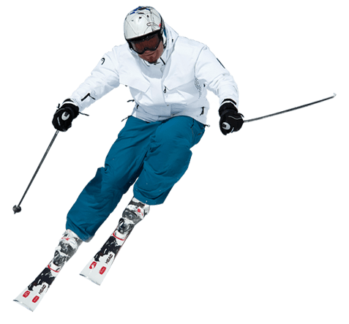 1. ----------------------------------------------------------
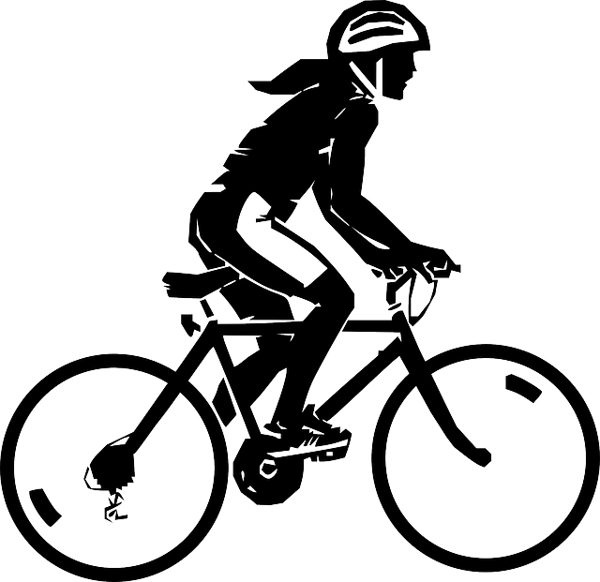 2. ----------------------------------------------------------------
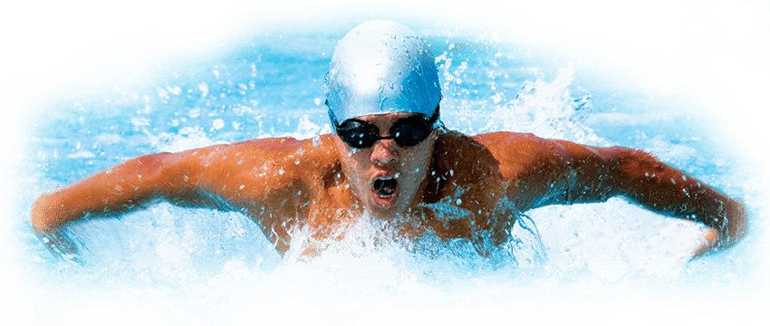 3. -----------------------------------------------------------------

Transcript :

Hi! I am Sheila and I am 11 years old.
I love sports but I can’t do them all because the weather changes very often in my country. I like outdoor sports like skiing, cycling and swimming.
When it is summer and the weather is really hot, I go swimming at my local beach every day and I swim for hours.
In winter time, my family and I go skiing to the Alps. What I really look forward to is spring when I spend most of the day riding my bike in the fields. Cycling is my favorite sport.

