Ex. 4 A1 Sports
Name: ____________________________ Surname: ____________________________ N^{ber}: ____ Grade/Class: _____
Assessment: _____________________________ | Date: ___________________________________________________
 | Teacher’s signature:  ___________________________ | Parent’s signature:  ___________________________
Listen and tick √ the sports most students of this school like.
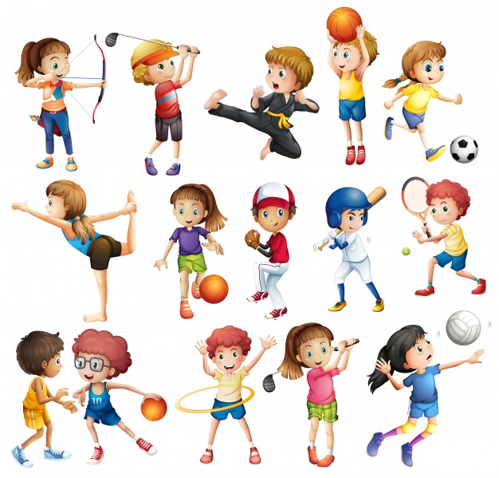

- Gymnastics -----------------
- Judo -----------------
- Cricket -----------------
- Hockey -----------------
- Volleyball -----------------

Transcript :

We love sports in my school and we can play them for hours. Most of the students enjoy doing gymnastics and judo because both of them exercise our body very well.
Another very popular sport is cricket and many students go after the lessons to play cricket at the pitch.

