Ex. 2 A1 sports
Name: ____________________________ Surname: ____________________________ N^{ber}: ____ Grade/Class: _____
Assessment: _____________________________ | Date: ___________________________________________________
 | Teacher’s signature:  ___________________________ | Parent’s signature:  ___________________________

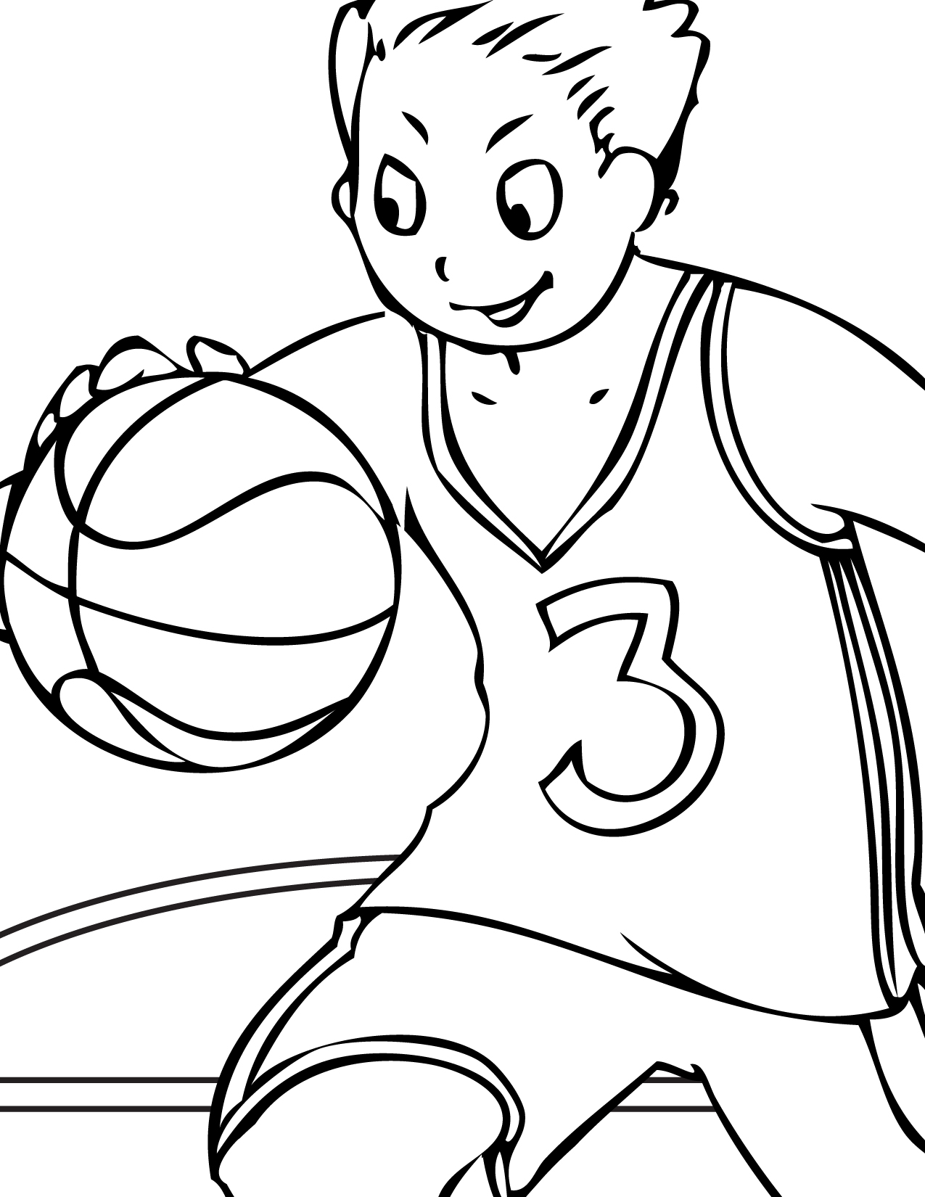

Read and colour John’s picture
John is playing basketball today with his school team. They must win to become champions. He is trying very hard.
He is wearing his team’s colours; a yellow basketball vest and a pair of blue shorts. The number on his vest is green and the ball is red.

