Ex3 A1 sports
Name: ____________________________ Surname: ____________________________ N^{ber}: ____ Grade/Class: _____
Assessment: _____________________________ | Date: ___________________________________________________
 | Teacher’s signature:  ___________________________ | Parent’s signature:  ___________________________

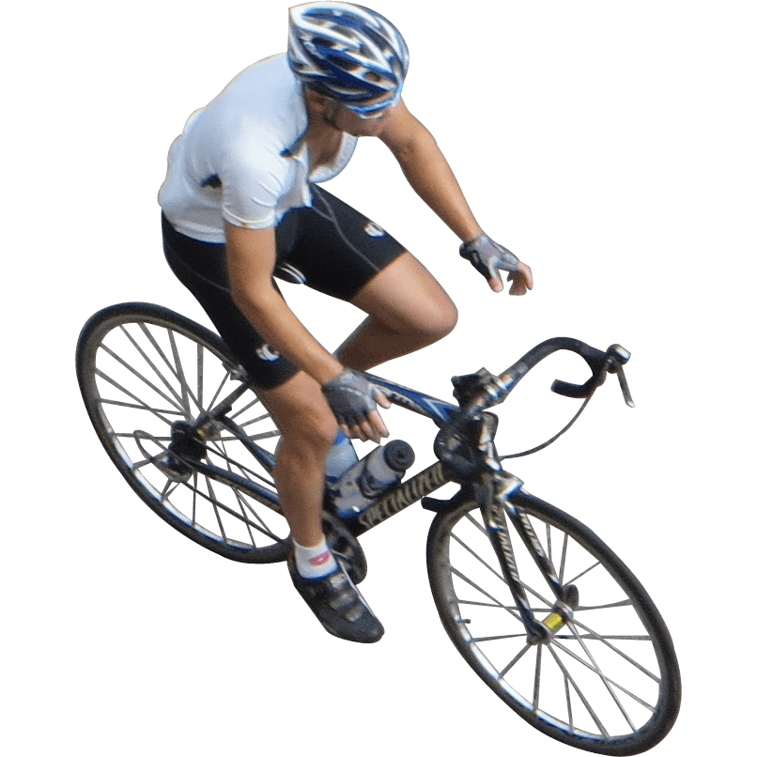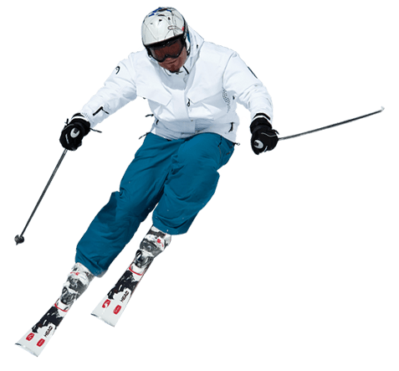

Samantha loves sports but she can’t do them all because the weather changes very often in her country. She likes outdoor sports like skiing, cycling and swimming.
When it is summer and the weather is really hot, she goes swimming at her local beach every day and she swims for hours.
In winter time, she goes skiing to the Alps. What she really looks forward to is spring when she spends most of the day riding her bike in the fields. Cycling is her favorite sport.

Answer the questions with YES or N0
- Does Samantha like outdoor sports? ______
- Does she go swimming in winter? ______
- Does she go skiing in the Alps? ______
- Is cycling her favorite sport? ______

