TOPIC: Sports | SUBTOPICS: Reading (Scanning) | LEVEL: A1
Name: ____________________________ Surname: ____________________________ N^{ber}: ____ Grade/Class: _____

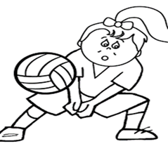

Read the text and write the name of the sport the students of ABC school play the following days

Our students like sports very much and they take part in many sports activities every week. Starting with Monday, there is a basketball tournament at our courts. On Tuesdays, there is a handball competition between classes.
On Wednesdays, there are very exciting volleyball matches between teachers and students. Finally, there are very hard football trainings on Fridays at our football pitch.

Monday ---------------------
Tuesday ---------------------
Wednesday ----------------------
Friday ----------------------

KEY
Mon- basketball Tue- handball Wed- volleyball Fri- football

