Exercise 2 A1 Sports
Name: ____________________________ Surname: ____________________________ N^{ber}: ____ Grade/Class: _____
Assessment: _____________________________ | Date: ___________________________________________________
 | Teacher’s signature:  ___________________________ | Parent’s signature:  ___________________________

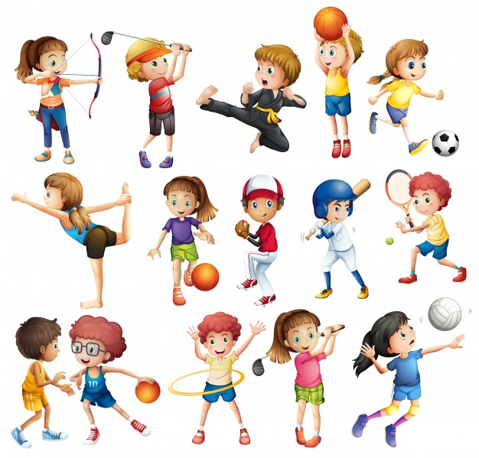

1. What sports can you see in the picture? (Student names 3-4 sports)
e.g. football

2. Which of the sports in the photo do you play with a ball?

3. What sports do you like?

