Exercise 2 A1 Sports
Name: ____________________________ Surname: ____________________________ N^{ber}: ____ Grade/Class: _____
Assessment: _____________________________ | Date: ___________________________________________________
 | Teacher’s signature:  ___________________________ | Parent’s signature:  ___________________________

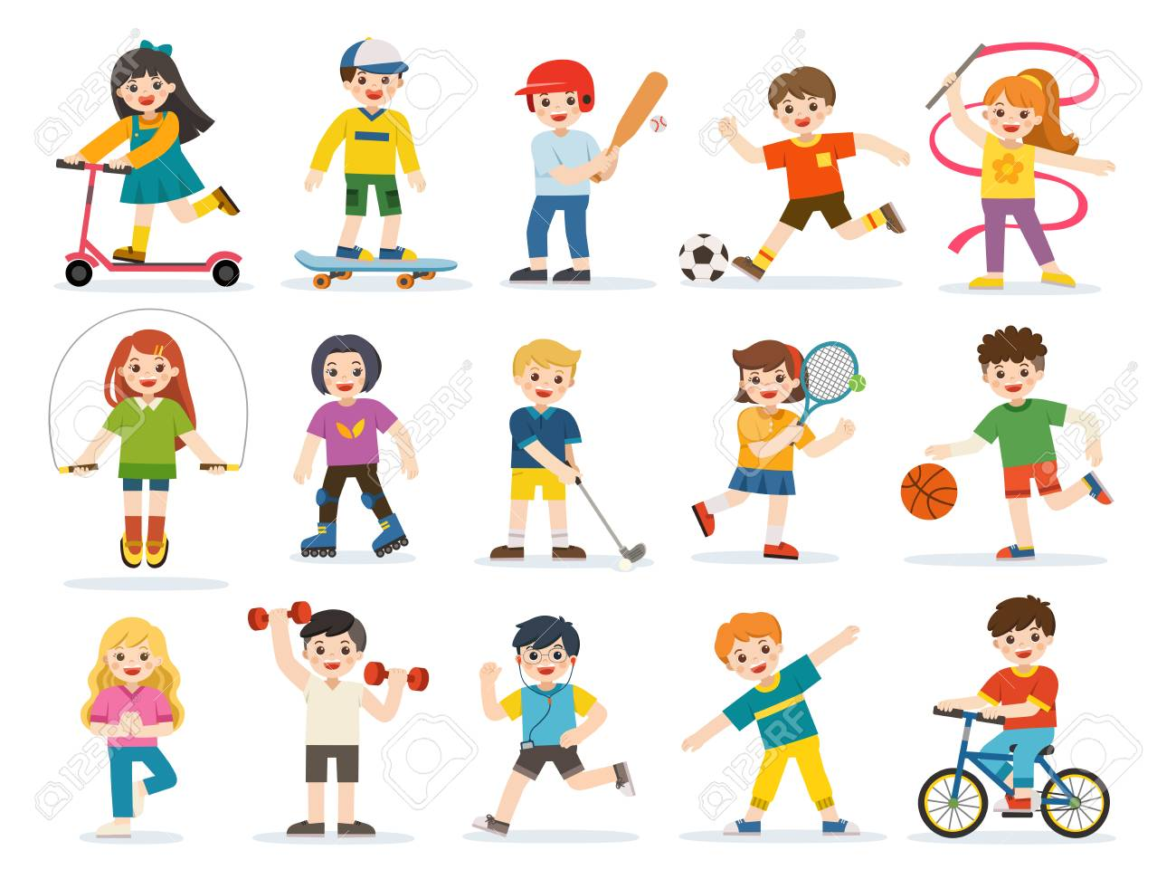

Look at the picture and say which sports you like and which you dislike

Which of these sports do you play or do?

What sports do your friends like?

