Exercise A1 Sports
Name: ____________________________ Surname: ____________________________ N^{ber}: ____ Grade/Class: _____
Assessment: _____________________________ | Date: ___________________________________________________
 | Teacher’s signature:  ___________________________ | Parent’s signature:  ___________________________
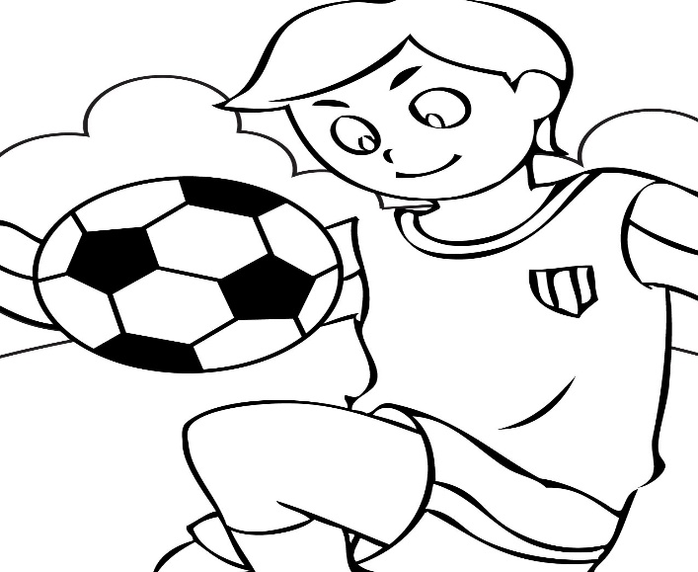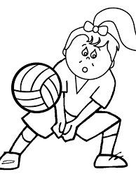

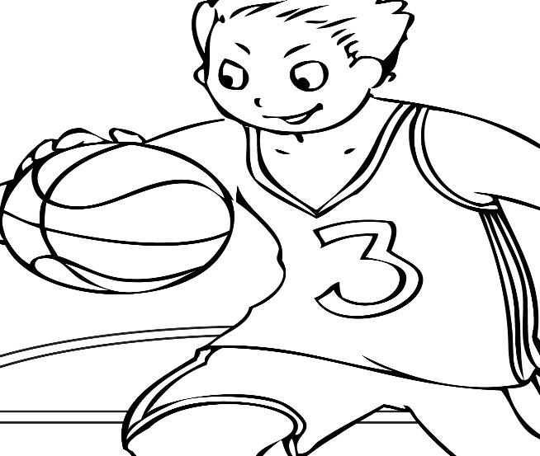

Look at these pictures and tell me which one is the odd one out and why.
Which of these 3 sports do you like the most and why?

