Ex. 5 A1 Speaking
Name: ____________________________ Surname: ____________________________ N^{ber}: ____ Grade/Class: _____
Assessment: _____________________________ | Date: ___________________________________________________
 | Teacher’s signature:  ___________________________ | Parent’s signature:  ___________________________

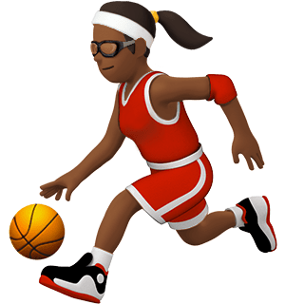
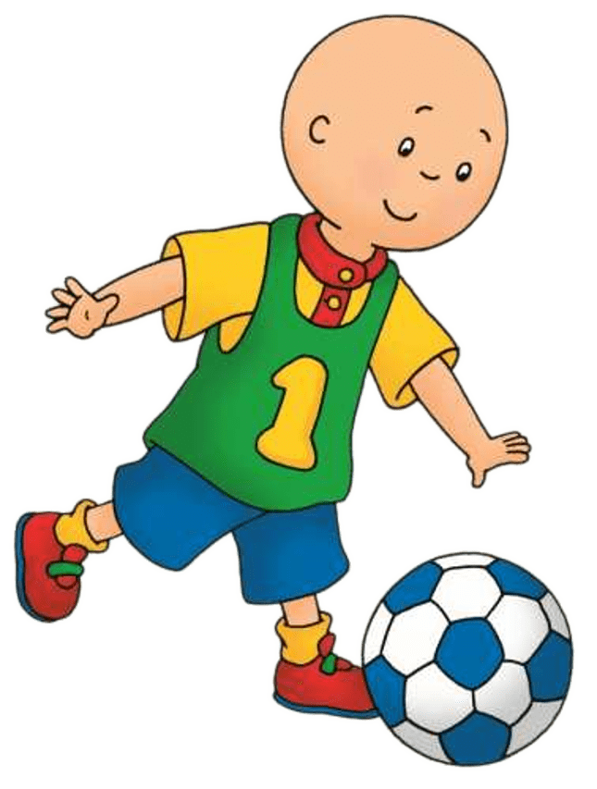
Look at the pictures and tell me why these sports are different.
e.g. You play basketball with your hands.
Which of these three sports do you like the most?
Do you practice any of these sports?

