Ex. A1 Sports
Name: ____________________________ Surname: ____________________________ N^{ber}: ____ Grade/Class: _____
Assessment: _____________________________ | Date: ___________________________________________________
 | Teacher’s signature:  ___________________________ | Parent’s signature:  ___________________________

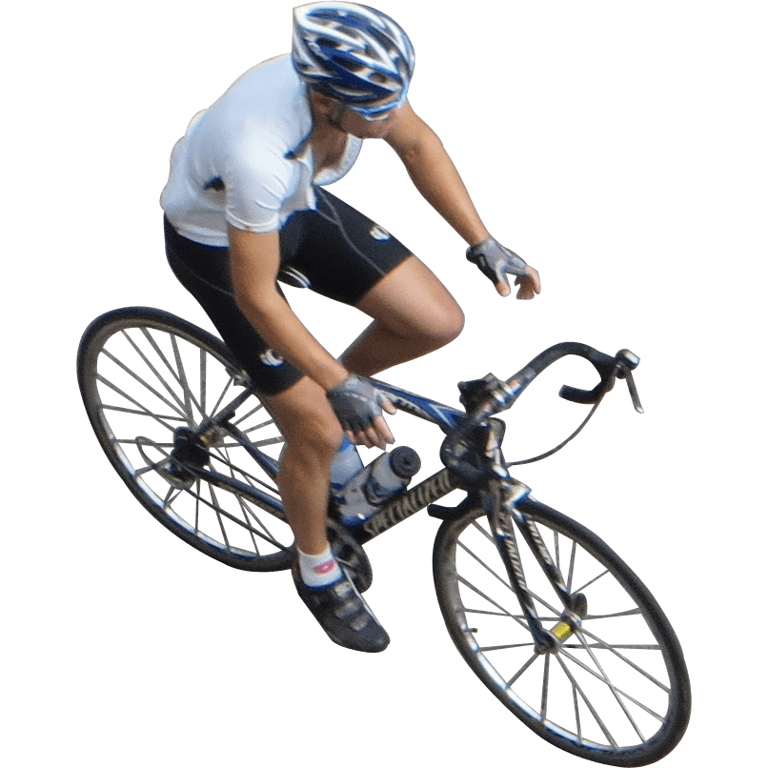

Can you tell me the name of these three sports and how they are different?
Do you do any of these sports at your school?

