TOPIC: Sports | SUBTOPICS: Vocabulary | LEVEL: A1
Name: ____________________________ Surname: ____________________________ N^{ber}: ____ Grade/Class: _____

Match the name of sport with the correct photo:
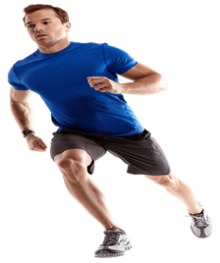 Swimming
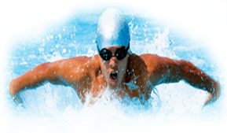 Basketball

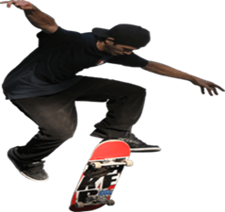 Running

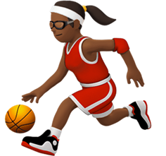 Skiing
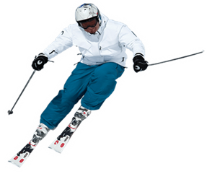 Skateboard

