Ex. 3 A1 sports
Name: ____________________________ Surname: ____________________________ N^{ber}: ____ Grade/Class: _____
Assessment: _____________________________ | Date: ___________________________________________________
 | Teacher’s signature:  ___________________________ | Parent’s signature:  ___________________________

1.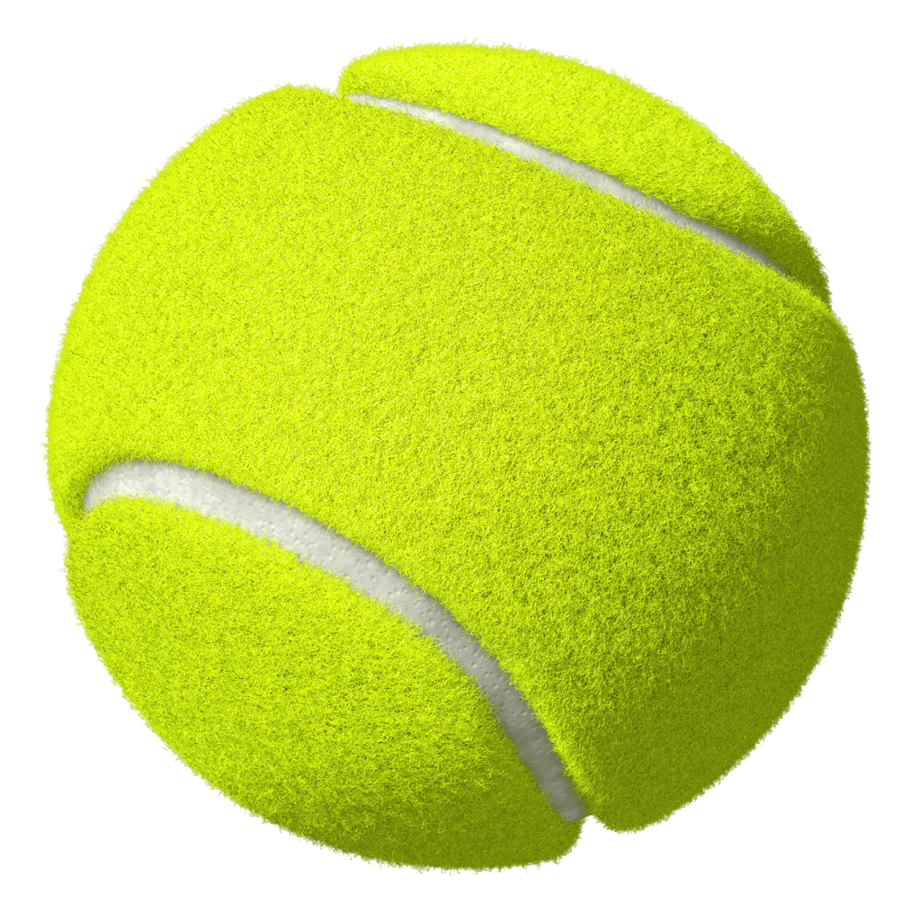2.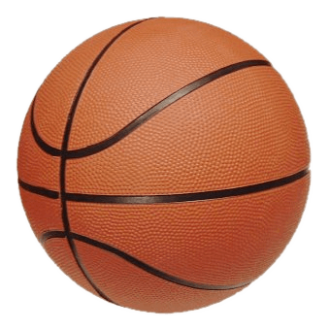
3.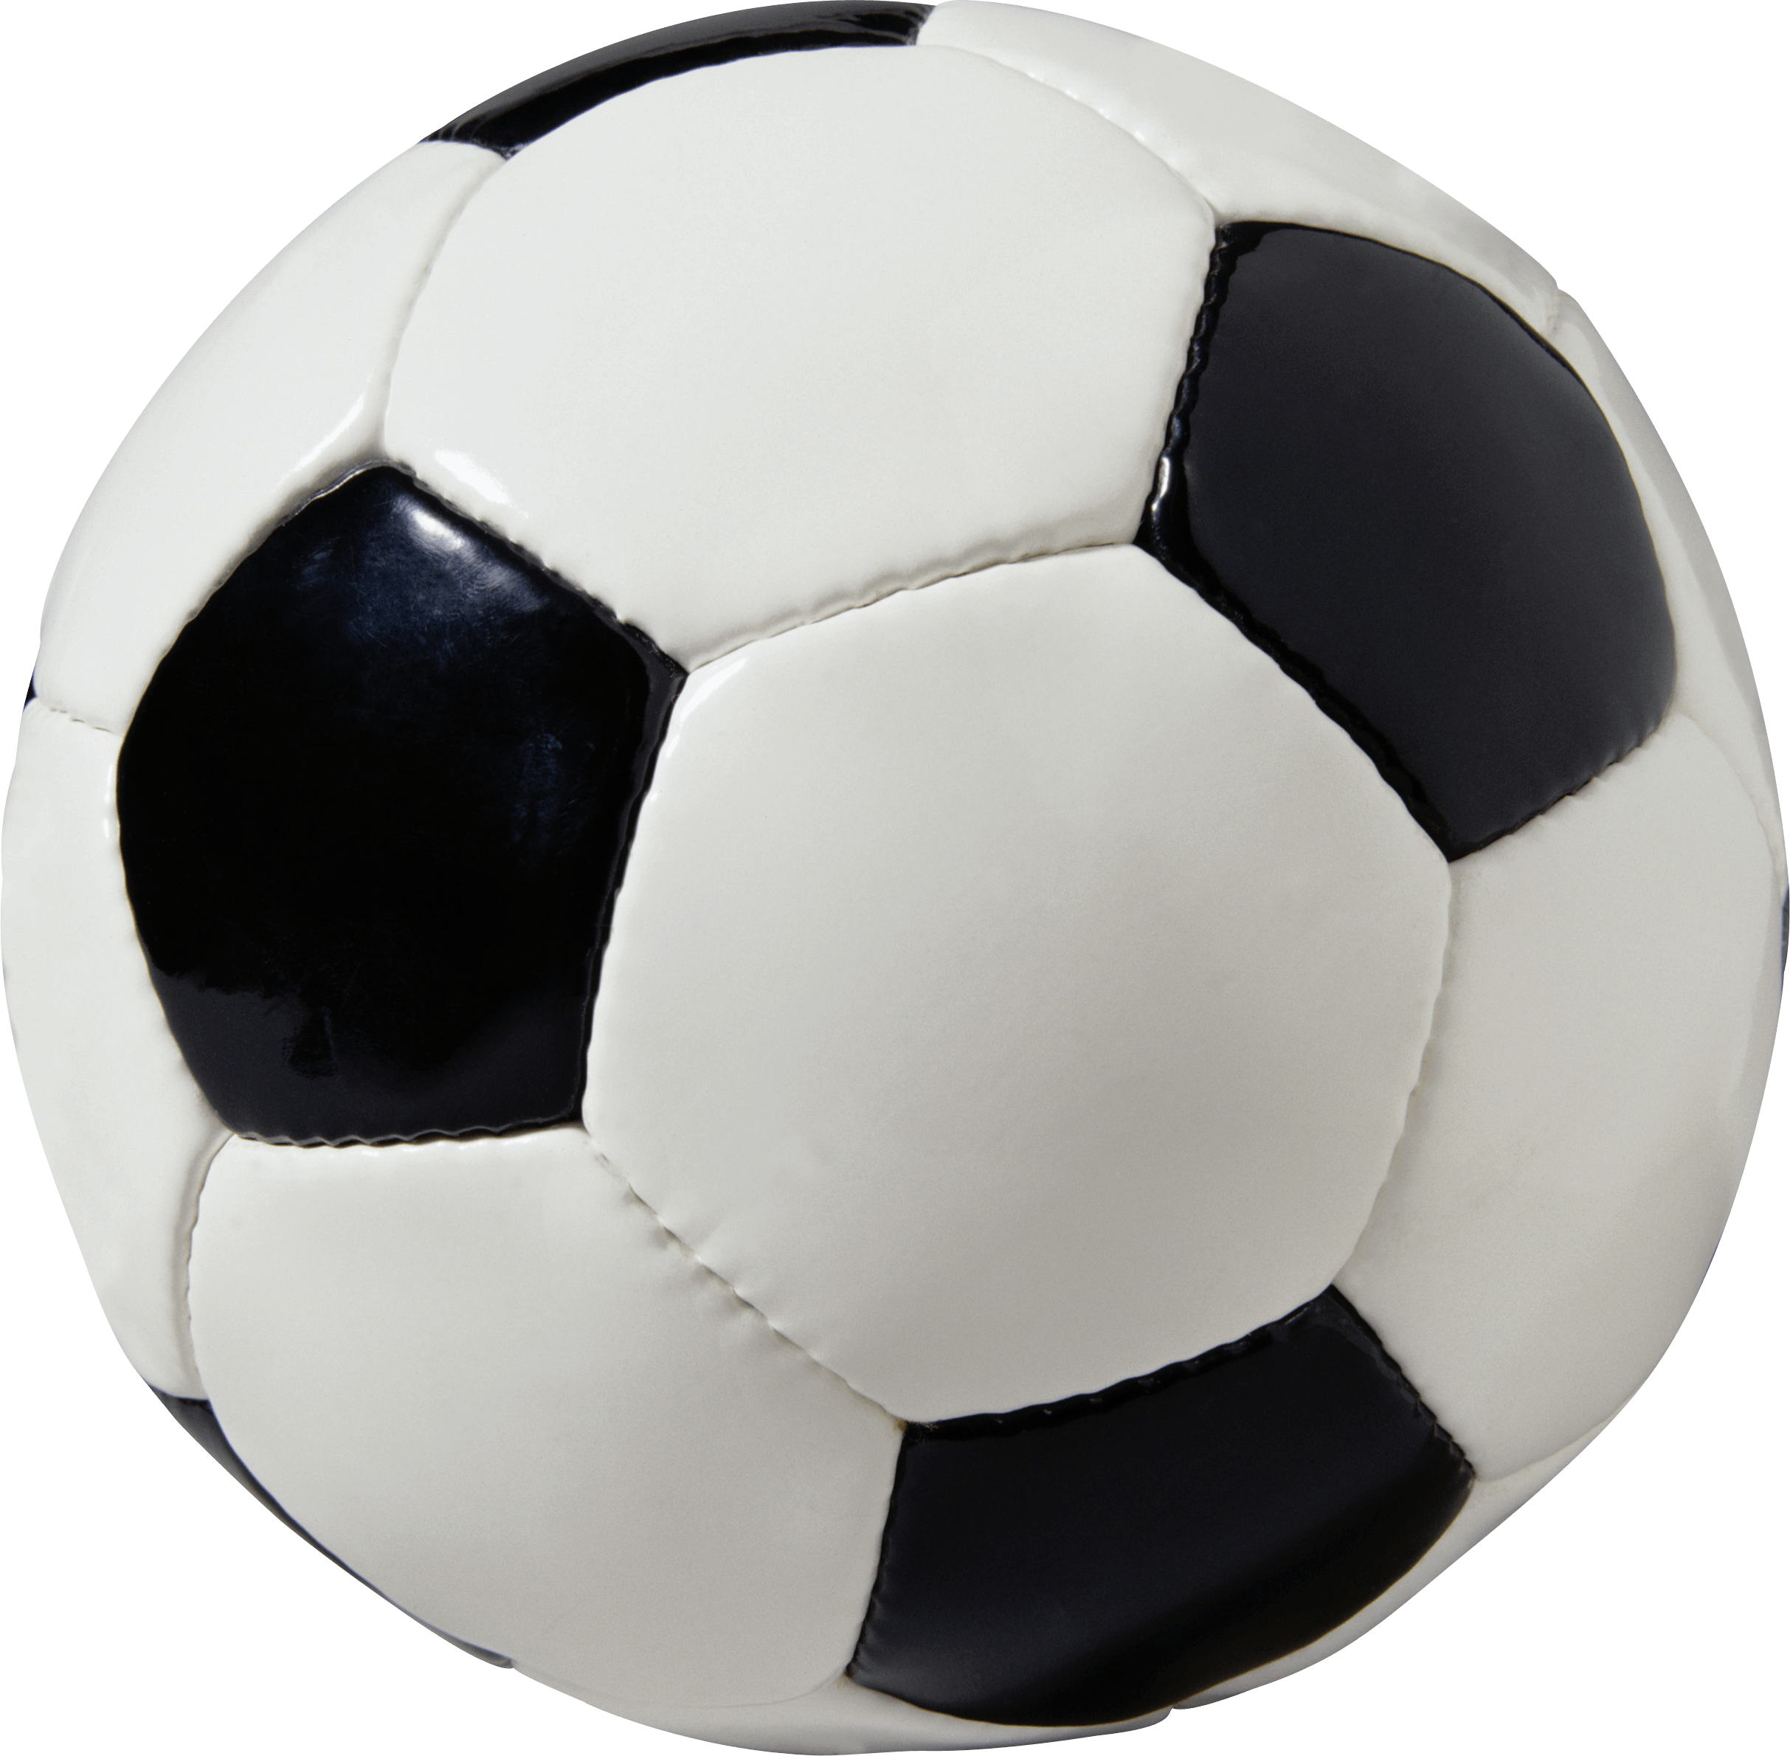
Write the name of the sports you can play with these balls.
- ----------------------------------------------------
- ---------------------------------------------------
- ----------------------------------------------------
Which are your favorite sports that you play with a ball and where do you play them?

