Ex4 A1 Sports
Name: ____________________________ Surname: ____________________________ N^{ber}: ____ Grade/Class: _____
Assessment: _____________________________ | Date: ___________________________________________________
 | Teacher’s signature:  ___________________________ | Parent’s signature:  ___________________________

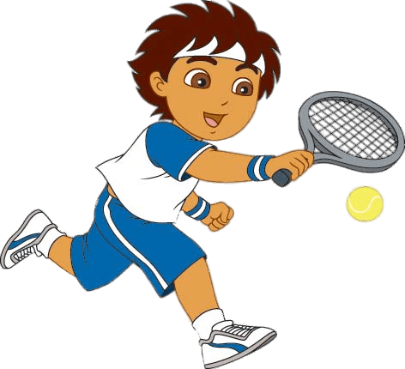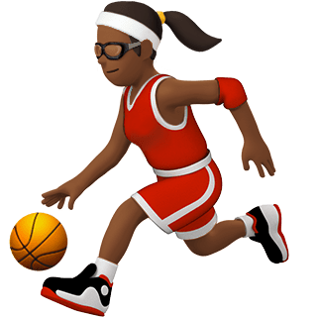
Write down 6 words you can see at these pictures which are about these sports e.g. Basketball boots
- ------------------------------- 2. -------------------------- 3. --------------------------
4. ---------------------------------- 5. --------------------------- 6. -------------------------

