Ex 5 A1 sports
Name: ____________________________ Surname: ____________________________ N^{ber}: ____ Grade/Class: _____
Assessment: _____________________________ | Date: ___________________________________________________
 | Teacher’s signature:  ___________________________ | Parent’s signature:  ___________________________

1.2.
3.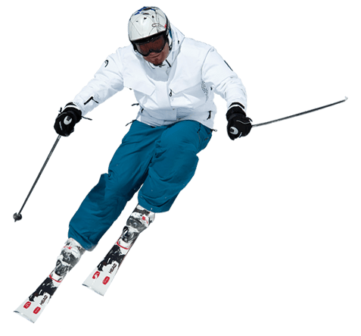4.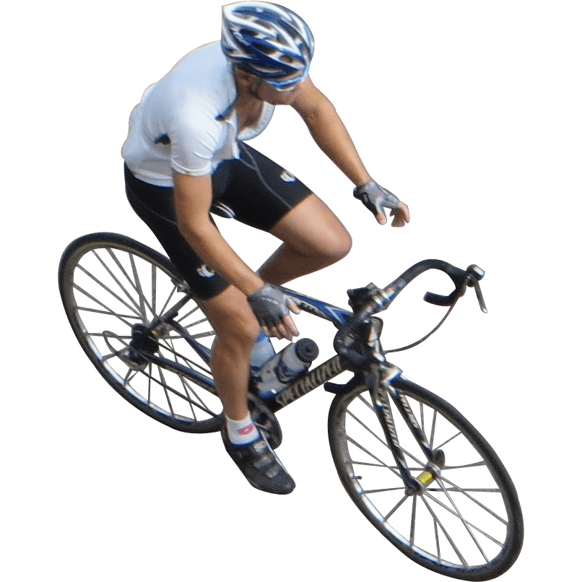

Write the name of these 4 sports shown in the pictures:

- ------------------------------------- 2. ---------------------------------------

3. ------------------------------------- 4. ------------------------------------

