Name: ____________________________ Surname: ____________________________ N^{ber}: ____ Grade/Class: _____
Assessment: _____________________________  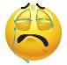 | Date: ___________________________________________________
 | Teacher’s signature:  ___________________________ | Parent’s signature:  ___________________________

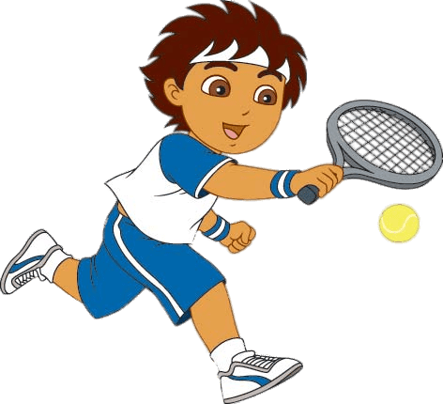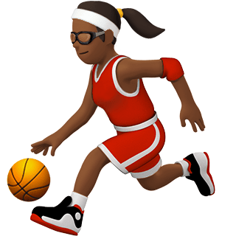
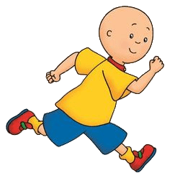
Write down 6 words you can see at these pictures which are about these sports e.g. Basketball boots
- ------------------------------- 2. -------------------------- 3. --------------------------
4. ---------------------------------- 5. --------------------------- 6. -------------------------

Marking Scheme 24 MARKS
Task Achievement - Two points for each answer given (12 Marks)
Excellent: 10-12
🙂👏
Very Good: 7-9
🙂
Satisfactory: 5-6
😐
Unsatisfactory: 3-4
☹️
Poor: 0-2
☹️

Language (Spelling) - Two points for each correctly spelled answer given (12 Marks)
Excellent: 10-12
🙂👏
Very Good: 5-9
🙂
Satisfactory: 4-6
😐
Unsatisfactory: 1- 3
☹️
Poor ☹️ 0-2

KEY
Racquet, tennis shoes, basketball boots, T-shirt, shorts, running, playing basketball, playing tennis, running shoes, trainers, socks, ribbon, socks

