Ex 1 A2 Sports
Name: ____________________________ Surname: ____________________________ N^{ber}: ____ Grade/Class: _____
Assessment: _____________________________ | Date: ___________________________________________________
 | Teacher’s signature:  ___________________________ | Parent’s signature:  ___________________________
Listen and tick √ the sport Jonathan likes doing in his free time.
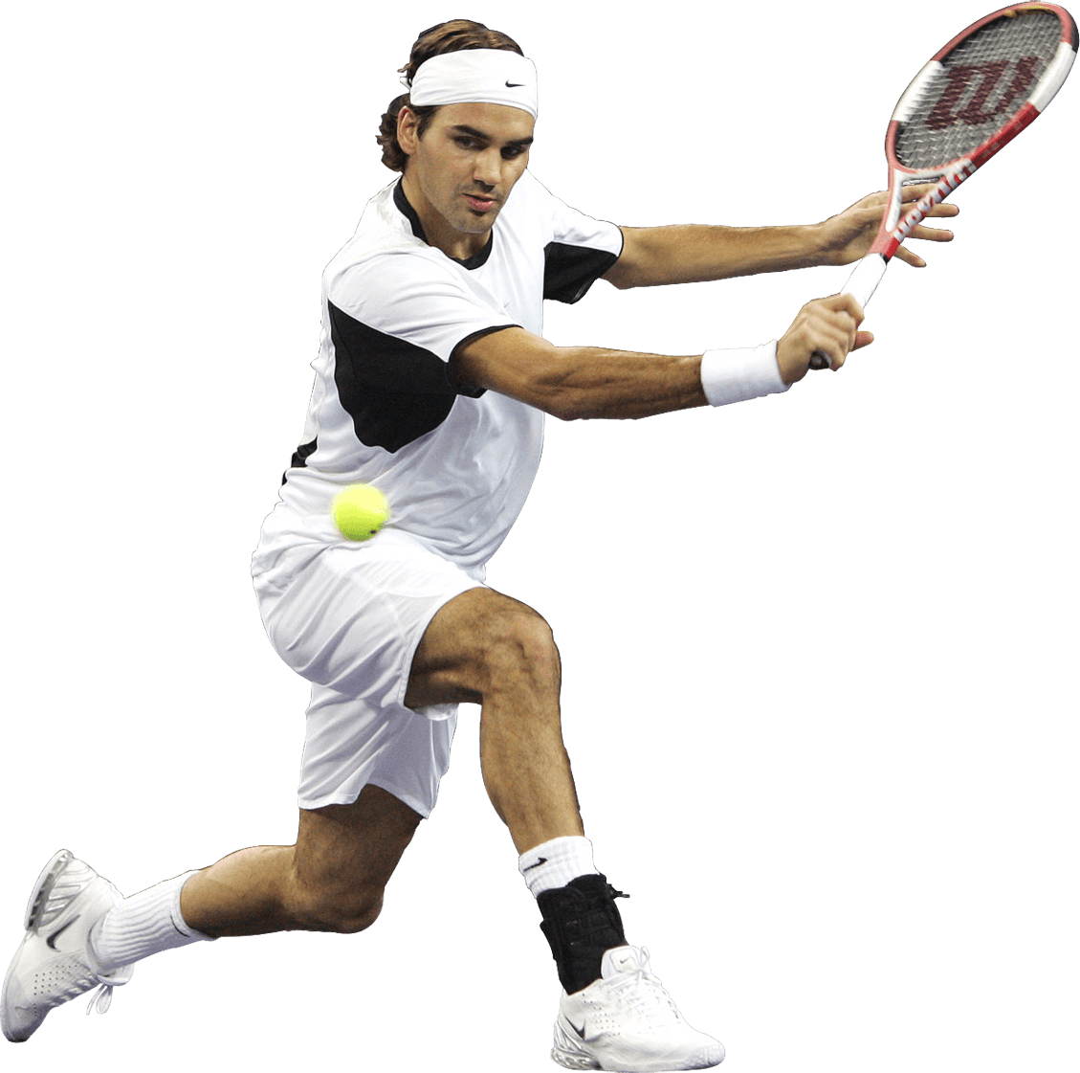 1. --------------------------

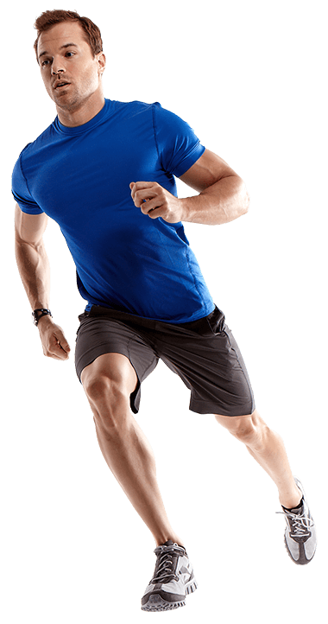 2. ------------------------------

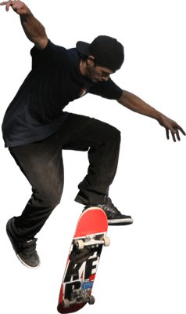 3. ---------------------------------

Transcript
My name is Jonathan and I am 12 years old.
Unfortunately, I don’t have much free time to practice sports because I have a lot of studying during the week..
There isn’t a football pitch in my neighborhood to play football nor a tennis court to play tennis.
What I really enjoy doing is skateboarding with my friends at the local square or at the park. I can stay there for hours doing stunts at the weekends.

