Ex 2 A2 Sports
Name: ____________________________ Surname: ____________________________ N^{ber}: ____ Grade/Class: _____
Assessment: _____________________________ | Date: ___________________________________________________
 | Teacher’s signature:  ___________________________ | Parent’s signature:  ___________________________
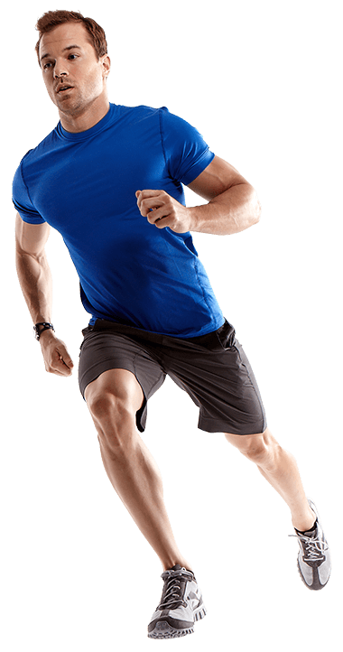

Listen and write the things you need to buy when you go jogging and want to play tennis:
For jogging you need:
1. ----------------------------
2. -----------------------------

For tennis you need:
3. ----------------------------
4. ----------------------------
5. -----------------------------

Transcript:
We don’t need so many things to buy to practice our favorite sports. For example, when you want to start running and go jogging in a park or a street all you need is a good pair of running shoes and a pair of shorts.
If you like to start playing tennis then you have to get a good racket, a pair of tennis shoes and a tennis ball.
So, if you have decided to start these sports, then get these things ..and good luck!!

