Exercise 3 A2 Sports
Name: ____________________________ Surname: ____________________________ N^{ber}: ____ Grade/Class: _____
Assessment: _____________________________ | Date: ___________________________________________________
 | Teacher’s signature:  ___________________________ | Parent’s signature:  ___________________________

Listen and colour
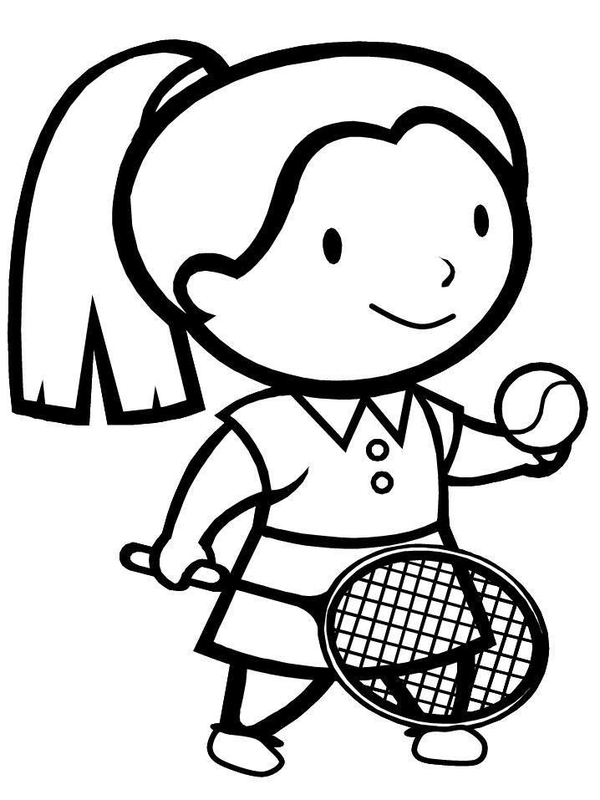 Mary
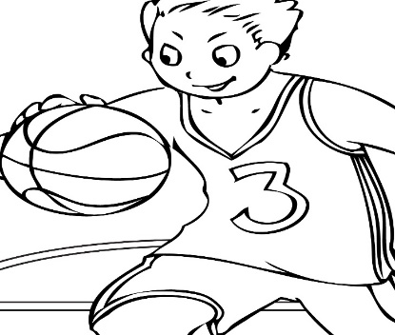 Peter

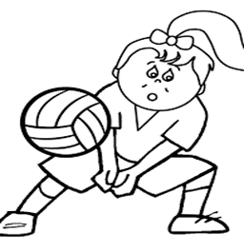 Pauline

Transcript:

It is a sports day today!! All pupils are playing sports!!
Peter is playing basketball and he is wearing a bright red T-shirt and blue shorts.
Pauline is playing volleyball with a yellow ball. She is wearing a green T-shirt

Mary is playing tennis and she is wearing a pair of lovely pink tennis shoes and she is holding a yellow tennis ball.

