Ex. 5 A2 Sports
Name: ____________________________ Surname: ____________________________ N^{ber}: ____ Grade/Class: _____
Assessment: _____________________________ | Date: ___________________________________________________
 | Teacher’s signature:  ___________________________ | Parent’s signature:  ___________________________

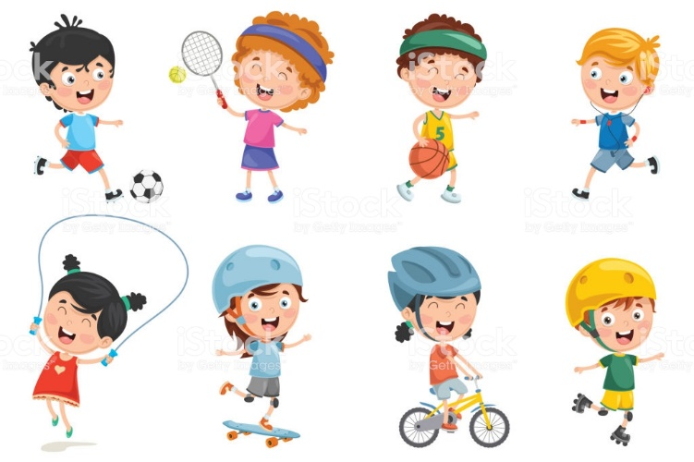

Listen and write the name of five (5) sports you can play at the new sports center:

1. --------------------------------------------------
2. --------------------------------------------------
3. --------------------------------------------------
4. --------------------------------------------------
5. --------------------------------------------------

Transcript

A new sports center opened in our town last week. You can do so many things and play so many sports there.
You can play tennis and volleyball. There is also a big football pitch where you can play football.
What I like most is the new basketball court where we play basketball for hours.
In the middle of the center, there is a small handball court for those who like playing handball.

