Ex 2 A2 Sports

|  |  |  |
| --- | --- | --- |
| **Name:** ____________________________ **Surname:** ____________________________ **Nber: ____ Grade/Class:** _____ | | |
| **Assessment:** _____________________________ | **Date:** ___________________________________________________ | |
| **Teacher’s signature:**  **___________________________** | **Parent’s signature:**  **___________________________** |

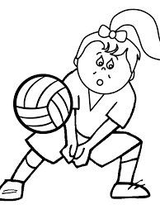

**Sports at School**

**At my school, there are many children who like volleyball and they play it on Tuesdays and Thursdays. Many times we go together with my friends to watch live volleyball matches at our town volleyball court.**

**Also, there is a basketball court at our school yard and most pupils stay after school on Mondays and Thursdays to play basketball with teams from other schools**

***Answer the questions***

1. **When do pupils play volleyball at school? _______________________________**
2. **Is there a basketball court at school? _______________________________**
3. **When do pupils play basketball at school? ________________________________**