A2 Sports
Name: ____________________________ Surname: ____________________________ N^{ber}: ____ Grade/Class: _____
Assessment: _____________________________ | Date: ___________________________________________________
 | Teacher’s signature:  ___________________________ | Parent’s signature:  ___________________________

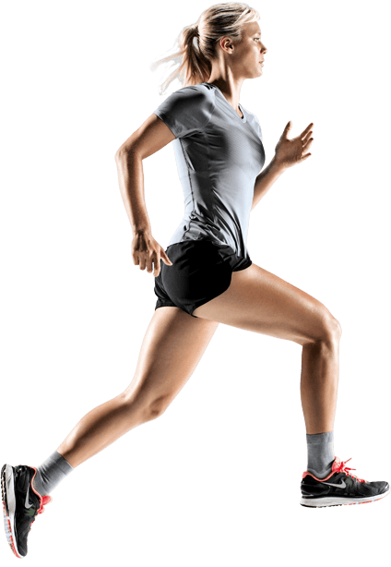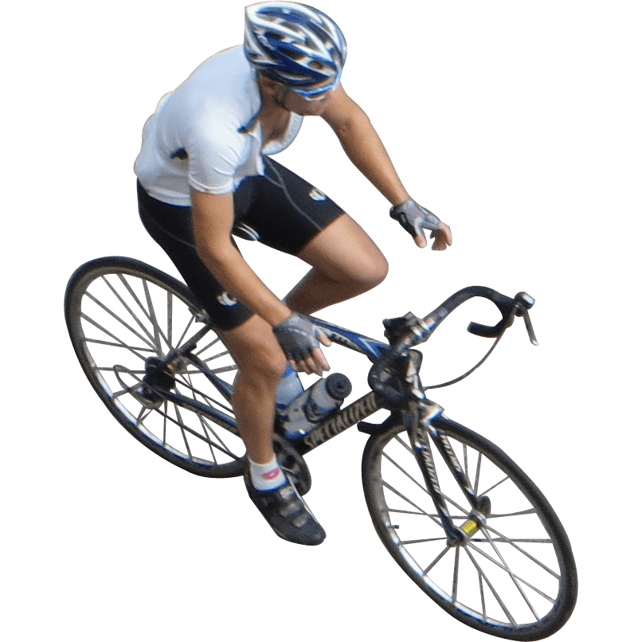

These two photos show two different sports.

Can you name these two sports?
What are their differences?
Which of these two sports do you like and why?

