A2 Sports
Name: ____________________________ Surname: ____________________________ N^{ber}: ____ Grade/Class: _____
Assessment: _____________________________ | Date: ___________________________________________________
 | Teacher’s signature:  ___________________________ | Parent’s signature:  ___________________________

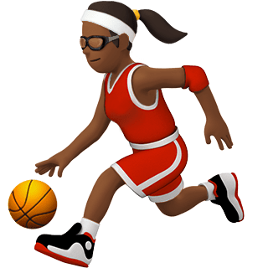
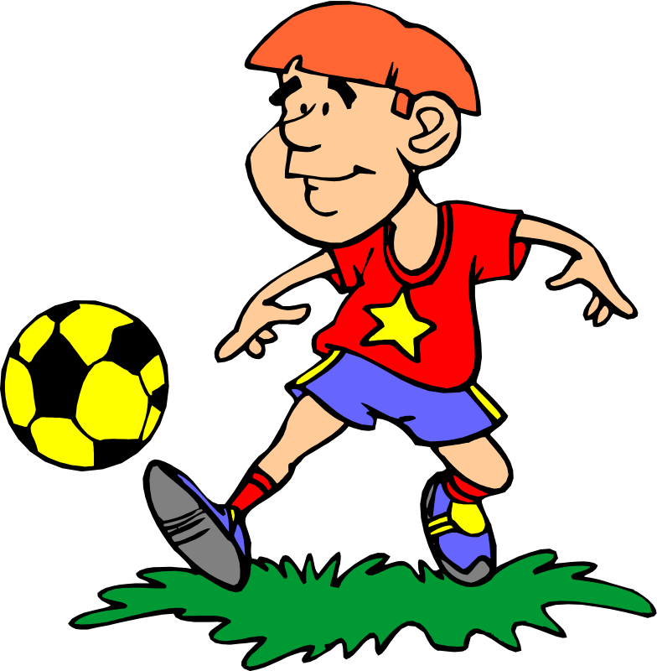These three sports are different. When you play football and basketball you need a ball but when you go jogging you don’t need a ball.

Can you tell me some other sports that you need a ball to play them and some others that you can do without a ball?

