A2 Sports
Name: ____________________________ Surname: ____________________________ N^{ber}: ____ Grade/Class: _____
Assessment: _____________________________ | Date: ___________________________________________________
 | Teacher’s signature:  ___________________________ | Parent’s signature:  ___________________________

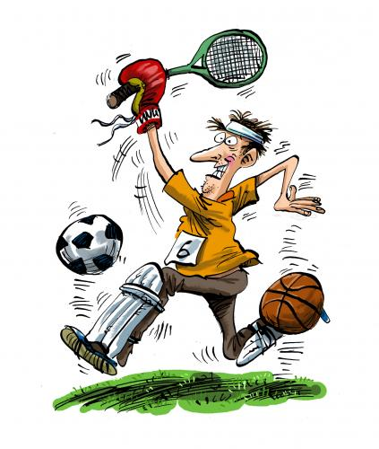
In this picture the man is doing many sports at the same time.
Can you tell me some of them?
Can you play more than one sport at the same time? (Why/why not?)
Do you have fun when you play sports with your friends?

