A2 Sports
Name: ____________________________ Surname: ____________________________ N^{ber}: ____ Grade/Class: _____
Assessment: _____________________________ | Date: ___________________________________________________
 | Teacher’s signature:  ___________________________ | Parent’s signature:  ___________________________

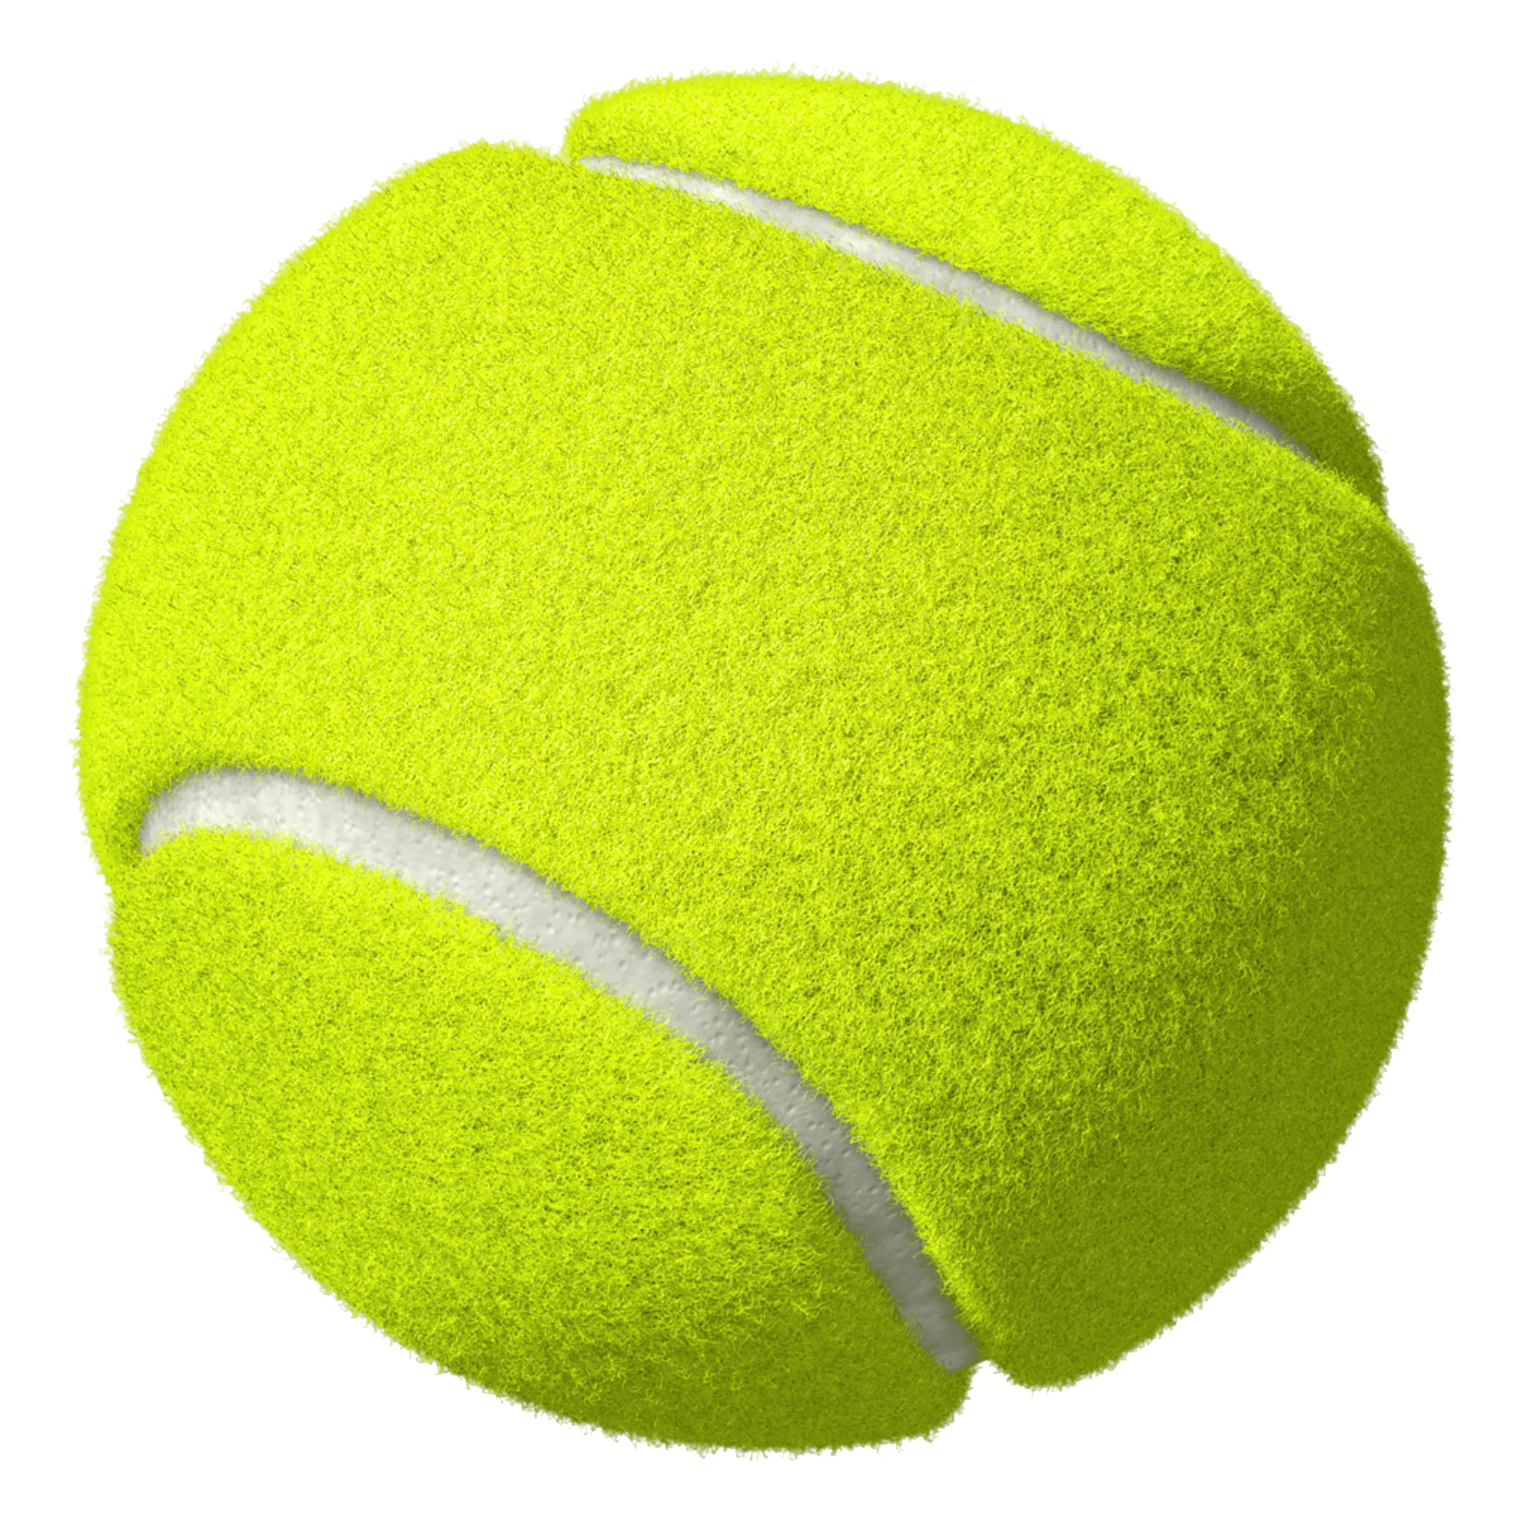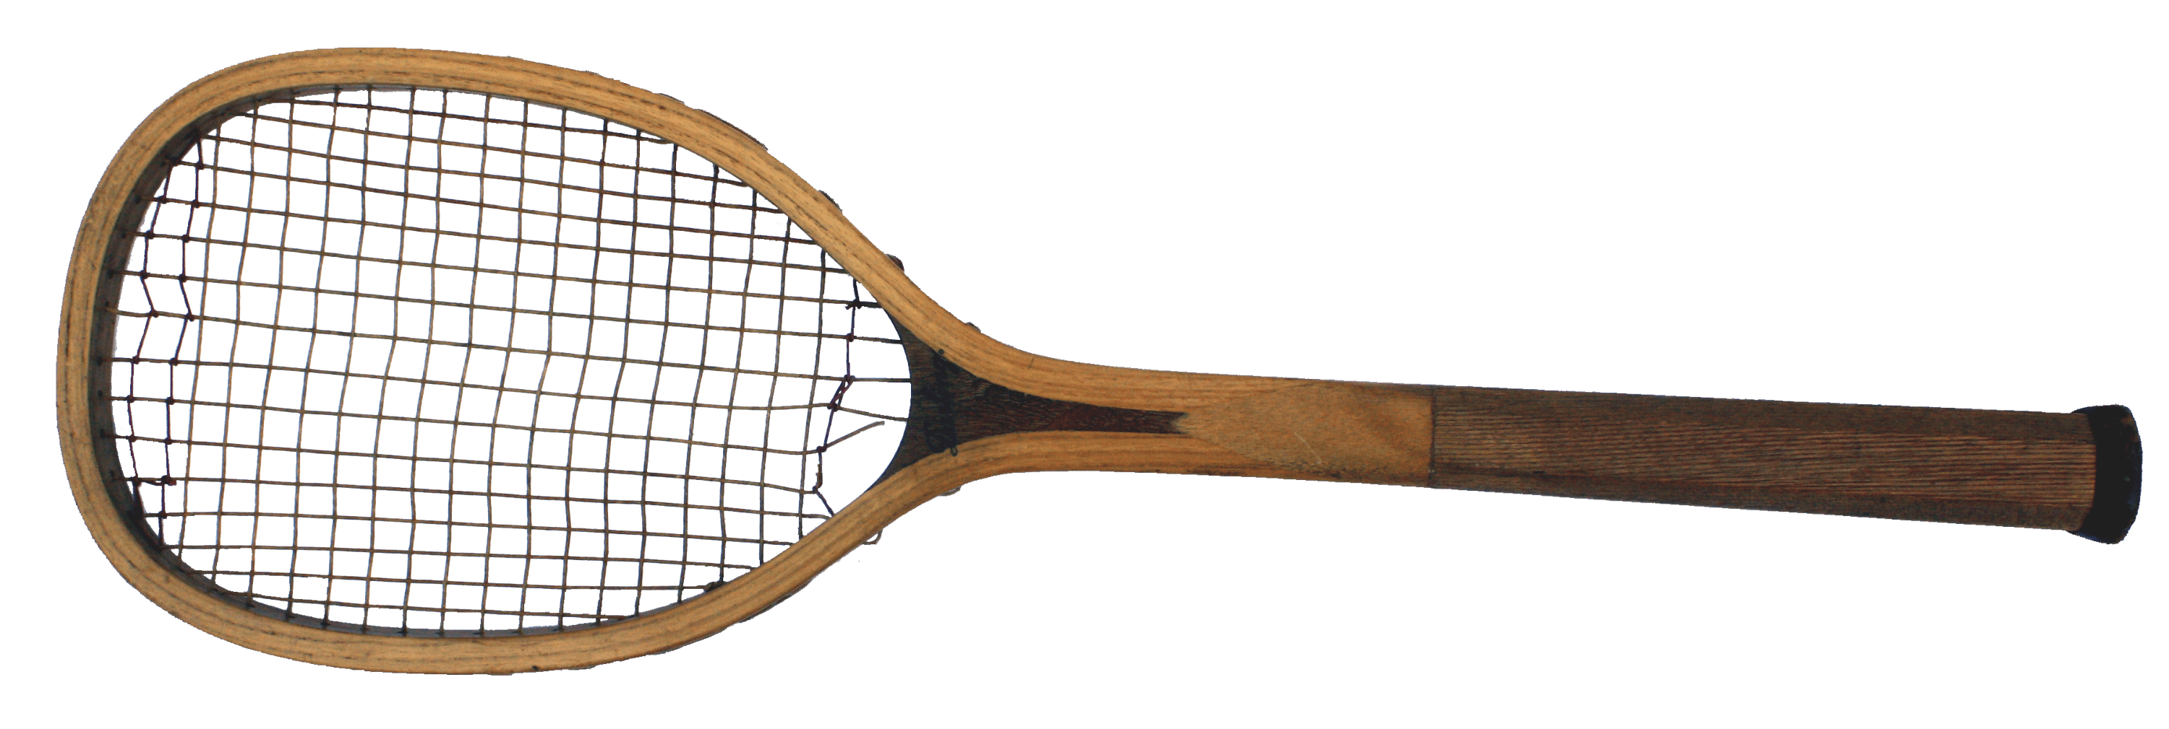

When you play tennis you need a tennis racket and a tennis ball. You play tennis at a tennis court.

Can you tell me what you need to have when you play football and basketball?
Where do you play football?
Where do you play basketball?

