A2 Sports
Name: ____________________________ Surname: ____________________________ N^{ber}: ____ Grade/Class: _____
Assessment: _____________________________ | Date: ___________________________________________________
 | Teacher’s signature:  ___________________________ | Parent’s signature:  ___________________________

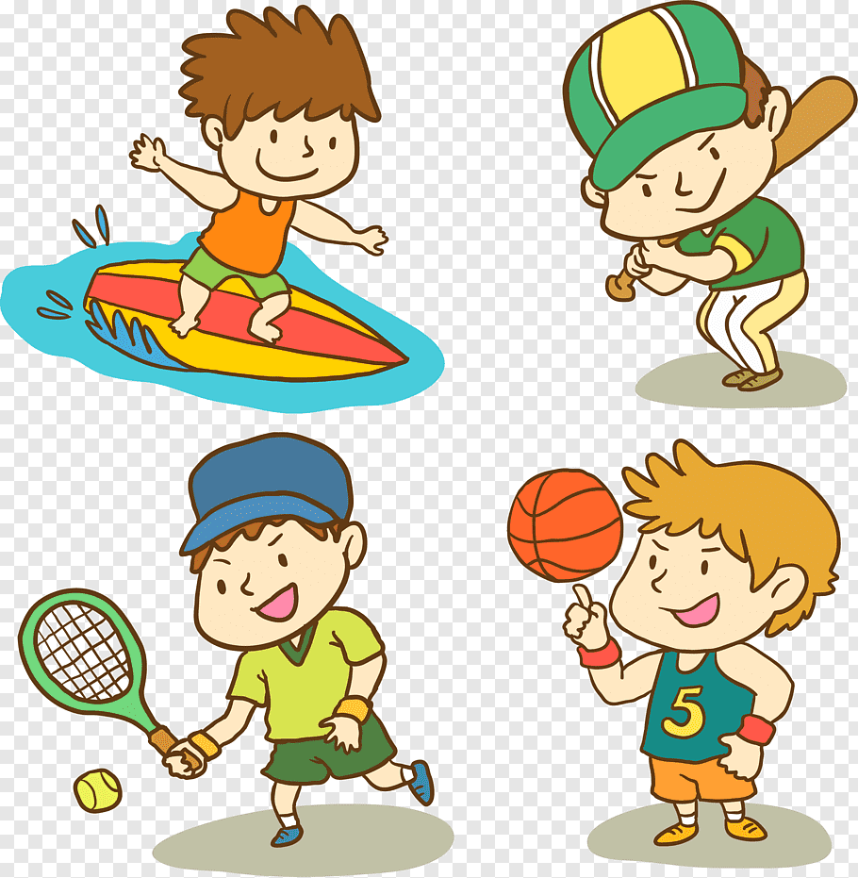

Which of these sports is completely different from the others? Why?
Do you like these sports? Why?
Which of these sports is the most popular in your country? Why?

