Ex1. A2 Sports
Name: ____________________________ Surname: ____________________________ N^{ber}: ____ Grade/Class: _____
Assessment: _____________________________ | Date: ___________________________________________________
 | Teacher’s signature:  ___________________________ | Parent’s signature:  ___________________________
Write the name of these sports next to their photographs. The first letter is written
S---------------------------------------------------------------------------
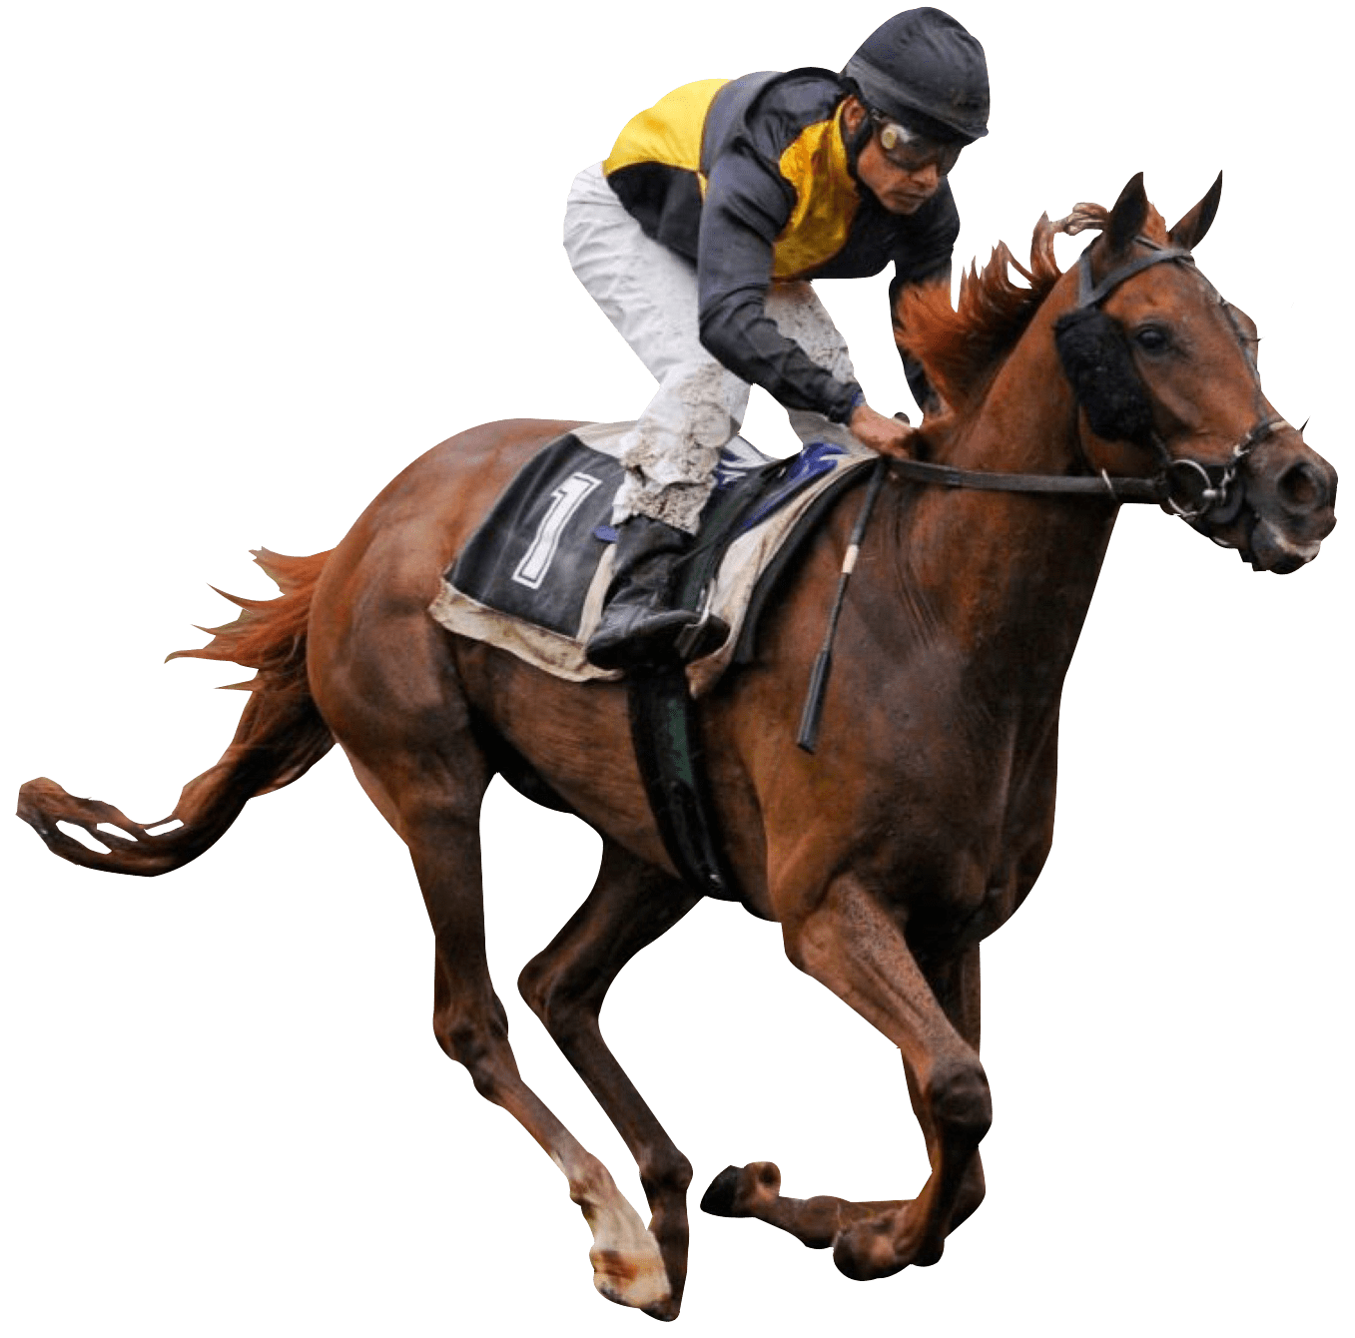H_______________________________________________
J--------------------------------------------------------------------------------------

