Ex. 2 A2 Sports
Name: ____________________________ Surname: ____________________________ N^{ber}: ____ Grade/Class: _____
Assessment: _____________________________ | Date: ___________________________________________________
 | Teacher’s signature:  ___________________________ | Parent’s signature:  ___________________________

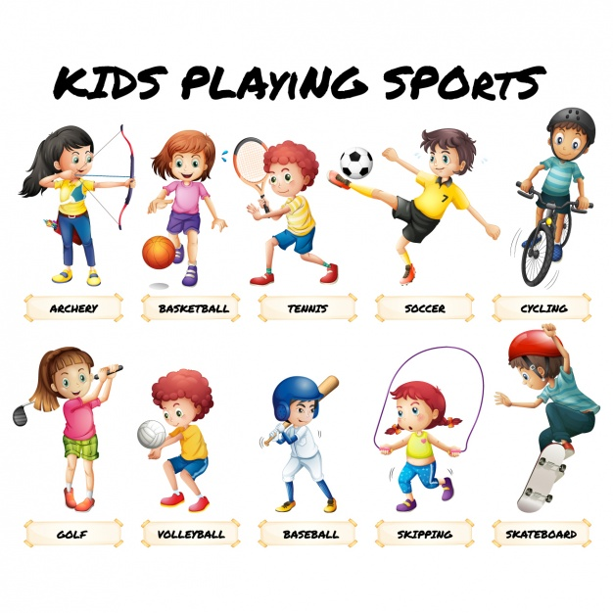
Sports in my town.
In my town, we love sports!! There are many sports clubs and gyms to practice the sport you like. There are so many sports you can choose from. Most of my friends like football and that is why there is football training every day at our local football pitch except Sundays.
Another very popular sport is hockey. We practice hockey three times a week; on Mondays, Wednesdays and Fridays.
Answer the following questions:
1. What sports do most people play in this town? -----------------------------------
2. How many times a week is there hockey training? -----------------------------------
3. When is there a football training? --------------------------------------------

