Ex. 3 A2 Sports
Name: ____________________________ Surname: ____________________________ N^{ber}: ____ Grade/Class: _____
Assessment: _____________________________ | Date: ___________________________________________________
 | Teacher’s signature:  ___________________________ | Parent’s signature:  ___________________________

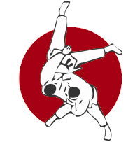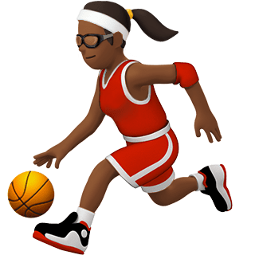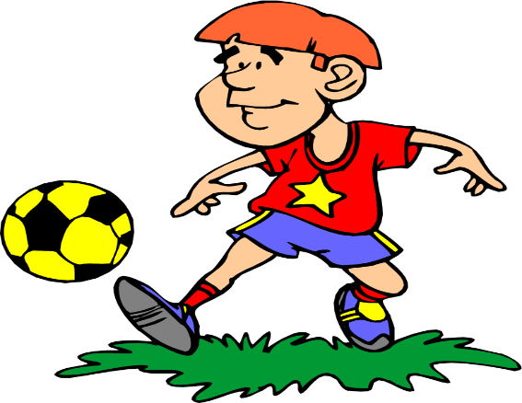
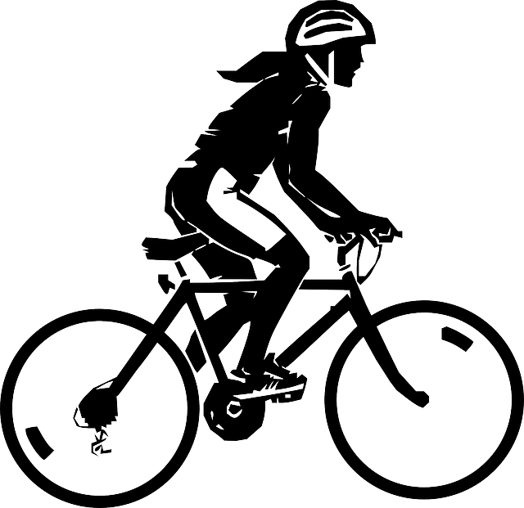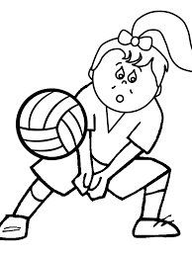
Write the name of the six sports you can see in the pictures
1. --------------------------------------------
2. --------------------------------------------
3. --------------------------------------------
4. --------------------------------------------
5. --------------------------------------------
6. ---------------------------------------------

