Ex. 4 A2 Sports
Name: ____________________________ Surname: ____________________________ N^{ber}: ____ Grade/Class: _____
Assessment: _____________________________ | Date: ___________________________________________________
 | Teacher’s signature:  ___________________________ | Parent’s signature:  ___________________________
Read and answer the questions
We don’t need so many things to buy to practice our favorite sports. For example, when you want to start running and go jogging in a park or a street all you need is a good pair of running shoes and a pair of shorts.
If you like to start playing tennis then you have to get a good racket, a pair of tennis shoes and a tennis ball. If you like swimming, all you need is a pair of swimming trunks or swimsuit and a pair of goggles!
For jogging you need: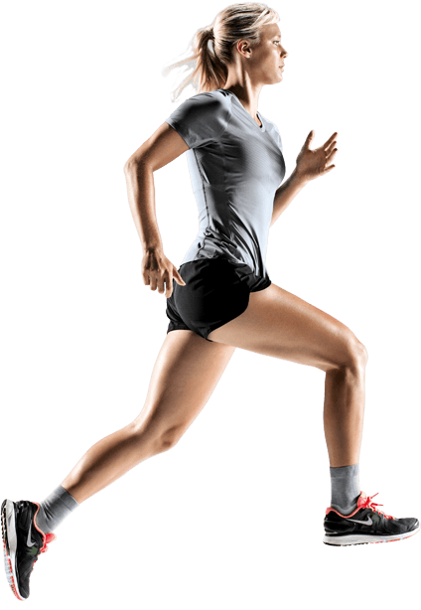
1. ----------------------------
2. -----------------------------
For tennis you need: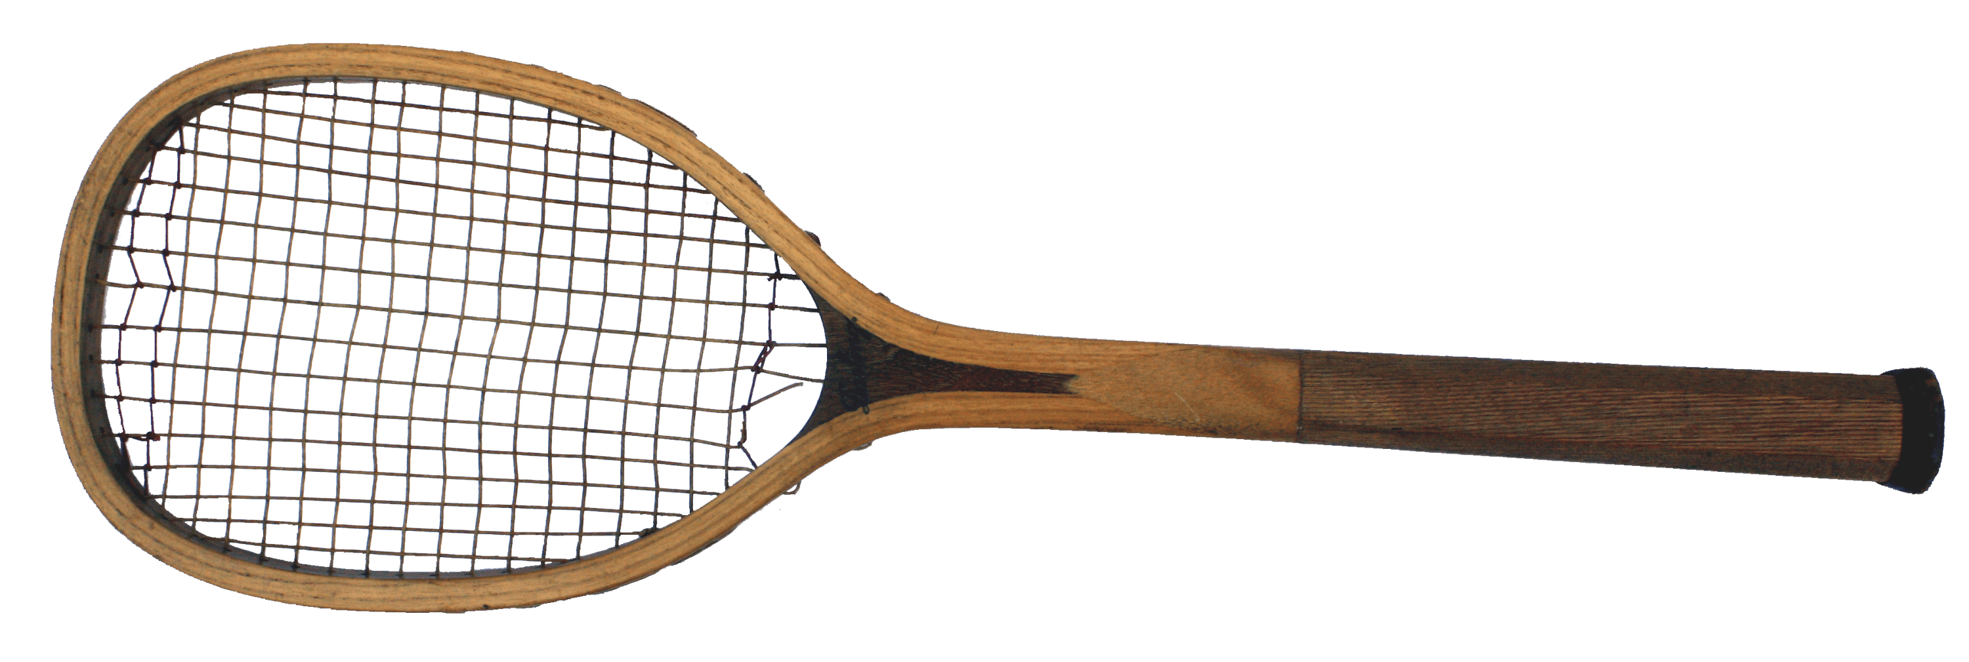
3. ----------------------------
4. ----------------------------
5. ----------------------------
For swimming you need: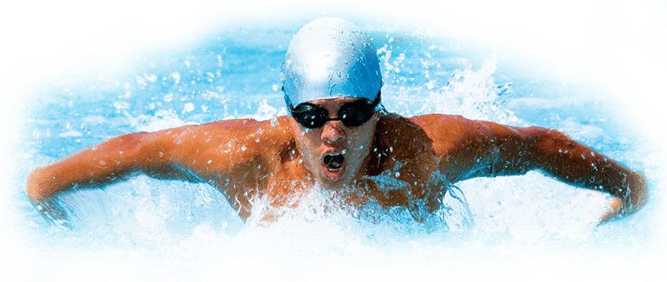
6. ------------------------------
7. ------------------------------

