Exercise 1 A2 Sports
Name: ____________________________ Surname: ____________________________ N^{ber}: ____ Grade/Class: _____
Assessment: _____________________________ | Date: ___________________________________________________
 | Teacher’s signature:  ___________________________ | Parent’s signature:  ___________________________

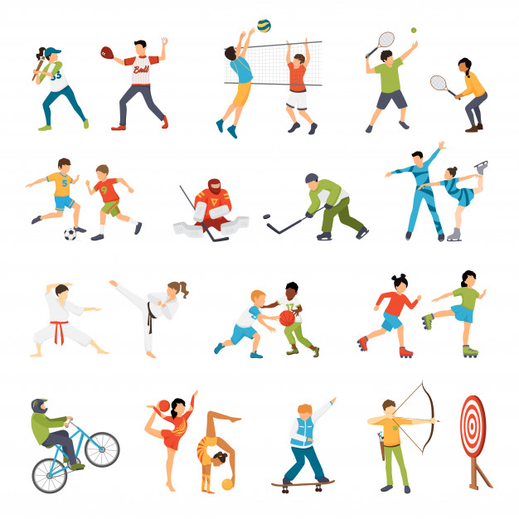
Write the name of five (5) sports you can see in the picture:
1. --------------------------------------------------
2. --------------------------------------------------
3. --------------------------------------------------
4. --------------------------------------------------
5. --------------------------------------------------

