Exercise A2 Sports
Name: ____________________________ Surname: ____________________________ N^{ber}: ____ Grade/Class: _____
Assessment: _____________________________ | Date: ___________________________________________________
 | Teacher’s signature:  ___________________________ | Parent’s signature:  ___________________________

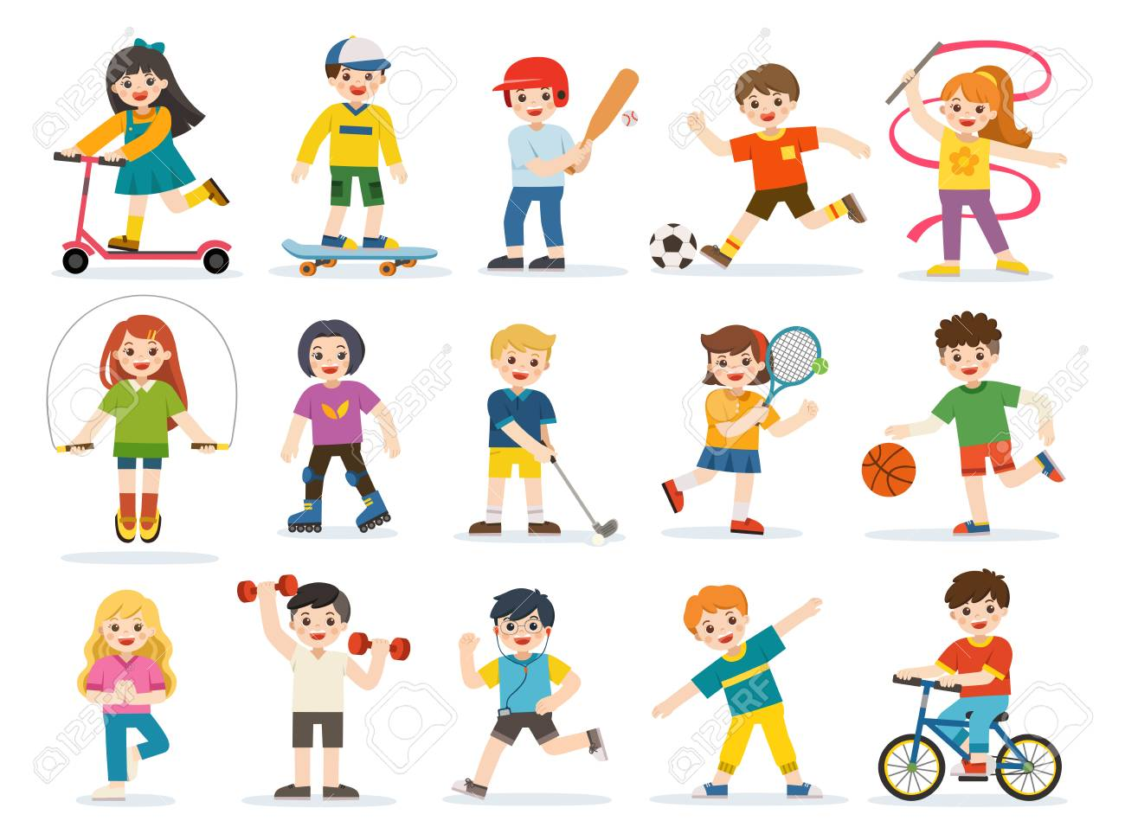
Write five sports you can see in the picture. e.g. Hockey

1. ---------------------------------------------------
2. ---------------------------------------------------
3. ---------------------------------------------------
4. ---------------------------------------------------
5. ----------------------------------------------------

