Ex. 3 A2 Sports
Name: ____________________________ Surname: ____________________________ N^{ber}: ____ Grade/Class: _____
Assessment: _____________________________ | Date: ___________________________________________________
 | Teacher’s signature:  ___________________________ | Parent’s signature:  ___________________________

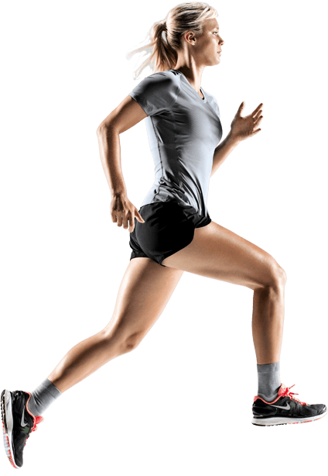

Choose the right word from the box and match it with the place that you can do or play the following sports.
One word must be used twice.
court/ pitch/ track/ rink/ring

- Tennis ---------------------------------------
- Football ---------------------------------------
- Basketball ----------------------------------------
- Boxing ---------------------------------------
- Ice-skating ---------------------------------------
- Athletics ---------------------------------------

