Ex.5 A2 Sports
Name: ____________________________ Surname: ____________________________ N^{ber}: ____ Grade/Class: _____
Assessment: _____________________________ | Date: ___________________________________________________
 | Teacher’s signature:  ___________________________ | Parent’s signature:  ___________________________

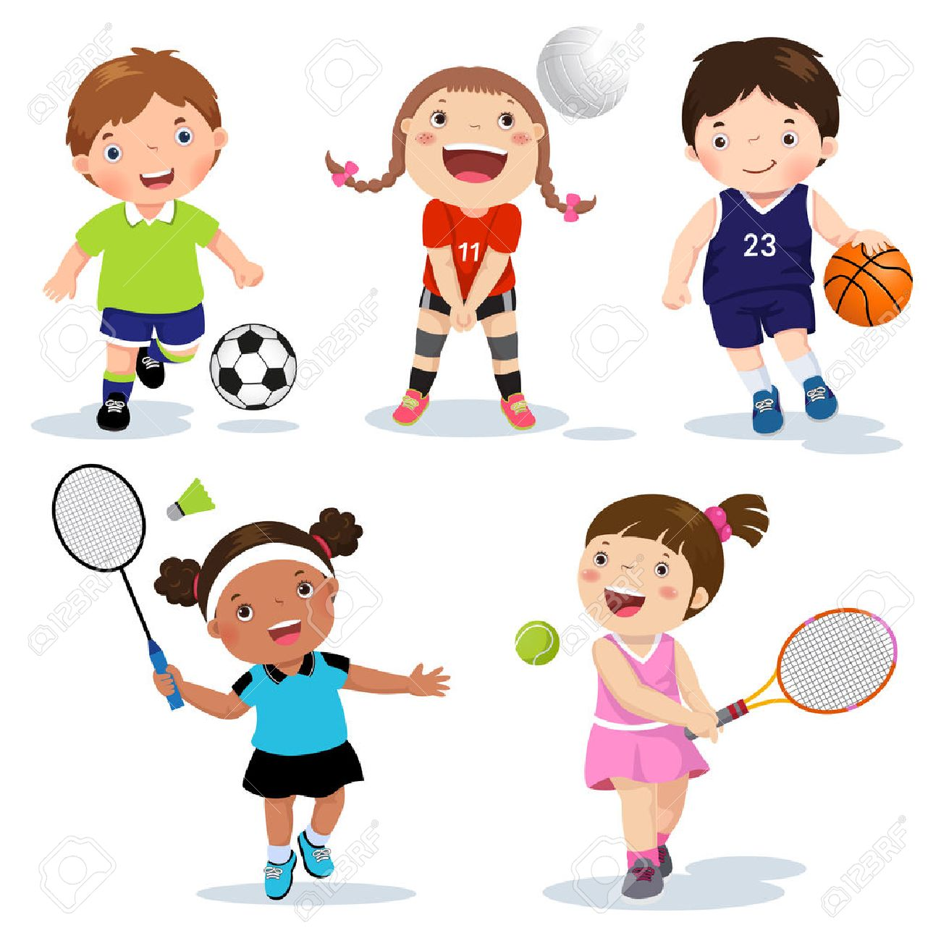

You need a ball to play most of the sports of this picture. Can you write 5 sports that you don’t need a ball to do them? E.g. Cycling

- -------------------------------------------
- -------------------------------------------
- -------------------------------------------
- -------------------------------------------
- -------------------------------------------

