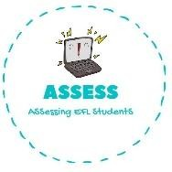
ENGLISH EXAM

Listening

Name: Surname: N^{ber}: Grade/Class:
Assessment: | Date:
 | Teacher’s signature:  _ | Parent’s signature:

1. Listen and number.

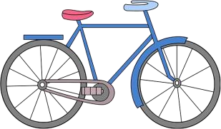
⚪ ⚪ ⚪

⚪ ⚪ ⚪
⚪ ⚪ ⚪

Assessing EFL Students

