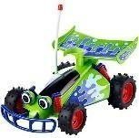
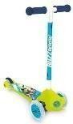
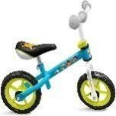
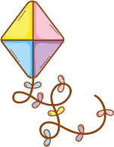

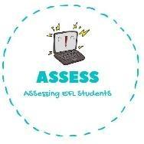
ENGLISH EXAM

Reading

Name: Surname: N^{ber}: Grade/Class:
Assessment: | Date:
 | Teacher’s signature:  _ | Parent’s signature:

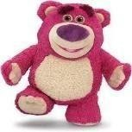
1. Choose the correct option.

1)  - Ball  - Bell  - Bill | 4)  - Doll  - Book  - Teddy bear
2)  - Race  - Car  - Cause | 5)  - Screen  - Bicycle  - Scooter
3)  - Bicycle  - Shoes  - Paint | 1)  - Kati  - Kite  - Keta

Assessing EFL Students

