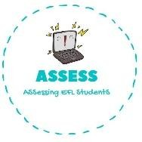
ENGLISH EXAM
Reading

Name: Surname: N^{ber}: Grade/Class:
Assessment: | Date:
 | Teacher’s signature:  _ | Parent’s signature:

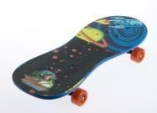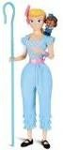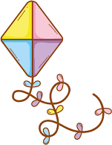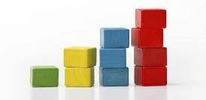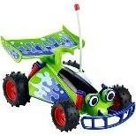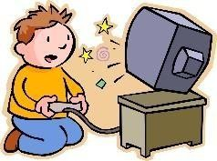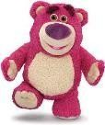1. Match the toys.

A) Doll
B) Computer games
C) Skate
D) Teddy bear
E) Car
F) Kite
G) Ball
H) Blocks

Assessing EFL Students

