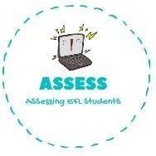
ENGLISH EXAM

Reading

Name: Surname: N^{ber}: Grade/Class:
Assessment: | Date:
 | Teacher’s signature:  _ | Parent’s signature:

1. Read and choose the toys they like.

Hello, my name is Ellie and I have a lot of toys. My favourite is the doll. | My name is Arthur. I like to play with trains.
Hi, I am Maria. My teddy bear is pink and smells like strawberries. | My brother plays with computer games.

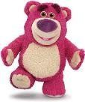

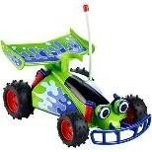
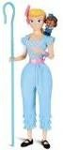
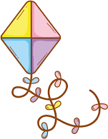
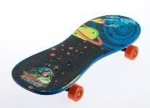

Assessing EFL Students

