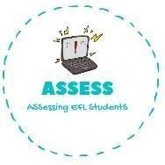
ENGLISH EXAM
Reading

Name: Surname: N^{ber}: Grade/Class:
Assessment: | Date:
 | Teacher’s signature:  _ | Parent’s signature:

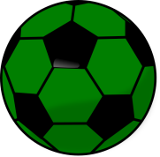
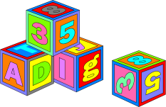
- Choose the correct answer.

Ball Blocks Doll
Blocks Chess Bike
Kite Computer games Train

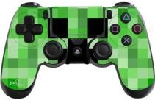
- Answer the questions: YES or NO.

Do you have a teddy? | YES NO
Do you have a bike? | YES NO
I have a teddy. | YES NO
I have a bike. | YES NO

Assessing EFL Students

