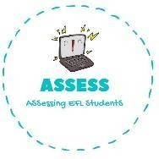
1. Draw the following toys.
Name: Surname: N^{ber}: Grade/Class:
Assessment: | Date:
 | Teacher’s signature: | Parent’s signature:

ENGLISH WORKSHEET

Reading

Car

Teddy bear

Assessing EFL Students

