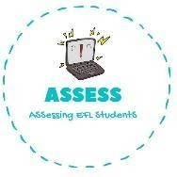
1. Draw the following toys.
Name: Surname: N^{ber}: Grade/Class:
Assessment: | Date:
 | Teacher’s signature: | Parent’s signature:

ENGLISH WORKSHEET

Reading

Pink Doll

Green Bike

Assessing EFL Students

