TOPIC: TOYS | SUBTOPICS: Naming toys | LEVEL: _A1
Name: Surname: N^{ber}: Grade/Class:

Match with arrows.
- Car.

- Computer game.
- Train.
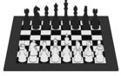
- Kite.
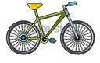
- Ball.
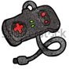
- Plane.
- Teddy bear.
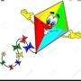
- Block.
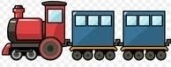
- Doll.
- Bike.
- Chess.

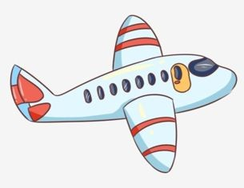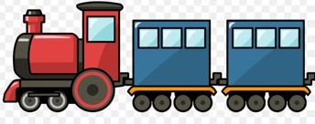

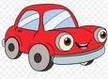

Talking about possession, write toys you have from de above and 3 that you don’t have.
I have got a… :
1
2
3

I haven’t got… :
1
2
3

Answer the questions:
How many cars are there? There are/there aren’t
How many trains are there? There are/there aren’t
How many bikes are there? There are/there aren’t

Say what color are your toys.
My is
My is

My is

