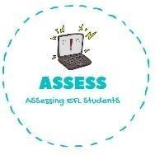
ENGLISH EXAM SPEAKING

Name: Surname: N^{ber}: Grade/Class:
Assessment: | Date:
 | Teacher’s signature:  _ | Parent’s signature:

1. Look at the pictures and answer the questions.

What colour is your toy?

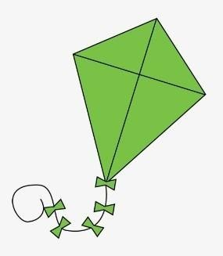
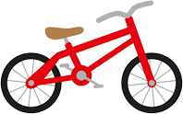
My ...... is ........ My ..... is ..... My ...... is .........

How many toys are there?
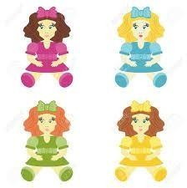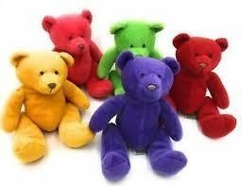

There are ...... ........ There are ....... ........ There are ....... ..............

Assessing EFL Students

