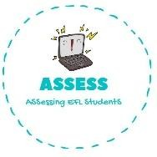
ENGLISH EXAM
Speaking

Name: Surname: N^{ber}: Grade/Class:
Assessment: | Date:
 | Teacher’s signature:  _ | Parent’s signature:

2. Ask your partner: “Have you got ...?” Put a tick (✓) or a cross (✕)

- Have you got a ball?
-Yes, I have. / No, I haven’t.

-Have you got cars?
-Yes, I have. / No, I haven’t.

-I have got a bike and a doll.
-I haven’t got blocks.

Assessing EFL Students

